Contents

STRUCTURES 2

INDIRECT AND INDEXED OPERANDS STRUCTS 20

PERFORMANCE OF ALIGNED AND MISALIGNED STRUCTS 27

STRUCTURES CONTAINING STRUCTURES 31

UNIONS IN ASSEMBLY 37

MACROS IN ASSEMBLY 40

ECHO AND LOCAL DIRECTIVES 44

CONDITIONAL ASSEMBLY DIRECTIVES 70

SPECIAL OPERATORS FOR MACROS 86

MACRO FUNCTIONS 93

REPEAT BLOCKS 96

STRUCTURES

Structures in Assembly Language

* A **structure** in assembly language is defined using the **STRUCT** and **ENDS** directives.
* A structure is a **user-defined data type** that groups related data together.
* Inside a structure, **fields (members)** are defined using the **same syntax as ordinary variables**.
* Each field has:
  + A **name**
  + A **data type** (BYTE, WORD, DWORD, QWORD, etc.)
* Structures can contain **many fields**, limited only by memory and practicality.
* The assembler automatically:
  + Calculates the **offset** of each field
  + Determines the **total size** of the structure
* Structures can include:
  + Simple data types (BYTE, DWORD, etc.)
  + Arrays
  + Other structures (nested structures)
* A structure definition **does not allocate memory** by itself.
* Memory is allocated only when a **structure variable** is declared using the structure type.
* Structures make assembly programs:
  + **More readable**
  + **Easier to maintain**
  + **More similar to high-level language data organization**

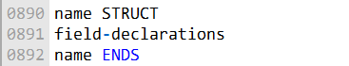

The following structure defines an employee structure:

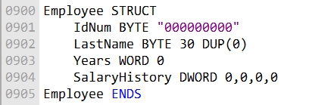

Structure Field Description

* **IdNum**
  + A **byte-sized field**
  + Initialized to the string **"000000000"**
  + Represents an ID stored as **ASCII characters**, not a numeric value
* **LastName**
  + A **30-byte array of bytes**
  + Initialized to **all zeros**
  + Typically used to store a null-terminated string
* **Years**
  + A **2-byte WORD**
  + Initialized to **0**
  + Often used to store years of service or age
* **SalaryHistory**
  + A **4-byte DWORD** *(or an array of DWORDs, depending on context)*
  + Initialized to **all zeros**

Note on DUP Operator

The **DUP operator** is used to create and initialize arrays.

Syntax example:

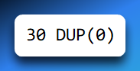

This creates an array of **30 bytes**, each initialized to **0**.

DUP is commonly used to:

* Zero-initialize strings
* Initialize arrays inside structures

Structure Memory Layout

*"In memory, a structure is stored as a contiguous block, with each field placed sequentially at the next available address. The diagram below illustrates the memory layout of the Employee structure."*

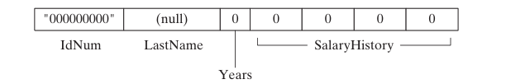

Memory Layout:

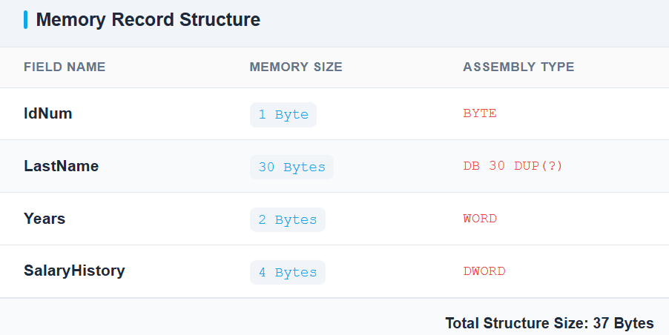

Using Structures in Assembly Language (MASM)

I. What Is a Structure?

A **structure** is a user-defined data type that groups related fields (members) under a single name.  
Each field has its own type, size, and offset within the structure.

Structures are mainly used to:

* Represent records (e.g., employees, students)
* Organize related data in memory
* Access fields using symbolic names instead of raw offsets



II. Declaring Structure Variables

General Syntax

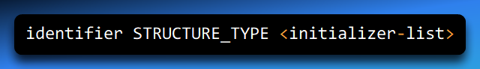

Components Explained

* **identifier**  
  Name of the structure variable (instance)
* **STRUCTURE_TYPE**  
  Name of the previously defined structure
* **initializer-list (optional)**
  + Values used to initialize structure fields
  + Must follow the **same order** as fields in the structure definition
  + Enclosed in angle brackets < >

Default Initialization

If the initializer list is **empty** or omitted:

* Fields are initialized to **default values**
* Numeric fields → 0
* Character fields → 0 or empty

Example

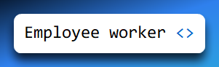

Explanation:

* Declares a structure variable named worker
* Type: Employee
* All fields are initialized to default values

III. Referencing a Structure Variable

Once a structure variable is declared, it behaves like a block of memory.

**Example**

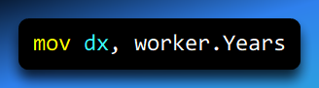

Accesses the Years field inside the worker structure

The assembler translates this into a memory access using:



IV. Referencing Structure Members (Dot Operator)

Syntax

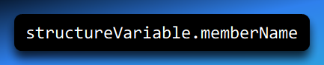

Explanation

* structureVariable → name of the structure instance
* memberName → name of a field inside the structure

Example

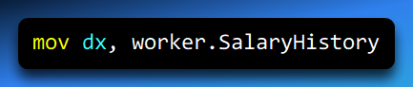

* Reads the SalaryHistory field from the worker structure
* This is the **preferred and safest** way to access structure members

V. Using the OFFSET Operator with Structures

**Purpose:** The OFFSET operator retrieves the **address** of a structure or one of its members — not the value stored there.

Syntax



Example

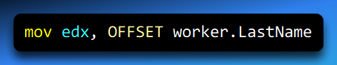

**What this does:**

* Loads the address of LastName into EDX
* Commonly used when:
  + Passing addresses to procedures
  + Working with string or array fields

VI. Declaring Multiple Structure Variables

You can declare multiple variables of the same structure type.

Example

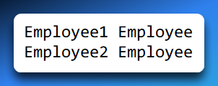

Explanation:

* Declares two independent structure instances
* Each occupies its own block of memory
* Fields are accessed independently

VII. Accessing Structure Fields (Dot Operator – Recommended)

Example

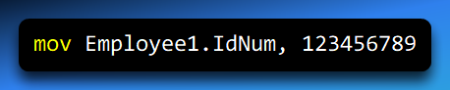

* Stores 123456789 in the IdNum field of Employee1
* Clear, readable, and offset-safe
* Automatically adapts if structure layout changes

VIII. Accessing Structure Fields Using Displacement (⚠ Advanced / Risky)

Syntax

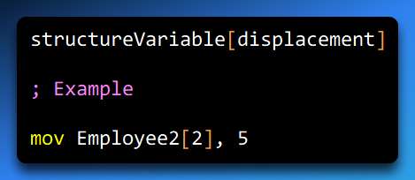

Explanation

* The displacement is measured **in bytes**, not fields
* It is calculated from the **start of the structure**
* In this example: Offset 2 happens to correspond to the Years field

⚠ **Important Correction (2022 note fix):**  
The displacement is **NOT** “the second field” — it is the **byte offset** of the field.

Why This Is Dangerous

* Breaks if:
  + Field sizes change
  + Fields are reordered
* Hard to read and maintain
* Easy to introduce bugs

Preferred approach:

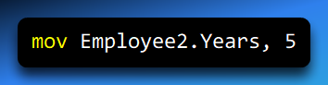

IX. Memory Layout Insight (Conceptual)

Example structure:

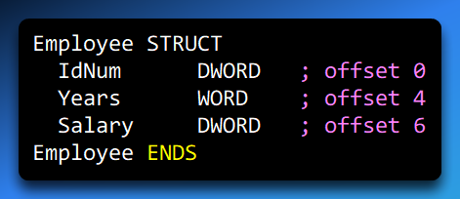

Visual Layout

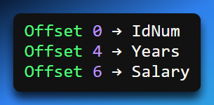

The assembler computes these offsets automatically when you use:



X. Common Pitfalls

* Confusing **field order** with **byte offset**
* Using hard-coded displacements instead of symbolic names
* Forgetting that OFFSET gives an address, not data
* Assuming structures behave like high-level language objects

XI. Key Takeaways

* Structures group related data into a single memory block
* Use **dot notation** for clarity and safety
* OFFSET is used when you need addresses
* Displacement access is possible but discouraged
* Assemblers compute field offsets — let them do it

Aligning Structure Fields

To achieve **optimal memory I/O performance**, structure members should be **aligned according to their data types**.

**Alignment** means placing data at memory addresses that are multiples of the data size.

A **BYTE** member should be aligned on a **byte boundary**.



A **WORD** member should be aligned on a **word (2-byte) boundary**.



A **DWORD** member should be aligned on a **doubleword (4-byte) boundary**.



Proper alignment allows the CPU to **access data in fewer memory cycles**.

If structure members are **not properly aligned**, the CPU may require **additional memory accesses**, reducing performance.

Assemblers may insert **padding bytes** between fields to maintain proper alignment.

The **Microsoft C/C++ compilers** and **Win32 API functions** follow specific alignment rules, as summarized in the alignment table (referenced below).

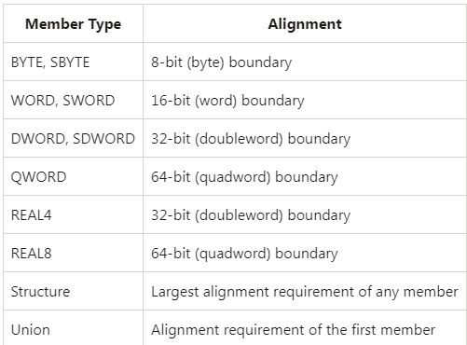

Data Alignment in Assembly Language (Structures & Variables)

I. What Is Data Alignment?

**Data alignment** means placing data in memory at addresses that are multiples of its size.  
Modern CPUs access aligned data more efficiently than unaligned data.

Example:

* A WORD (2 bytes) is best placed at an **even address**
* A DWORD (4 bytes) is best placed at an address divisible by **4**

II. Key Alignment Rules (x86)

Natural Alignment of Basic Data Types

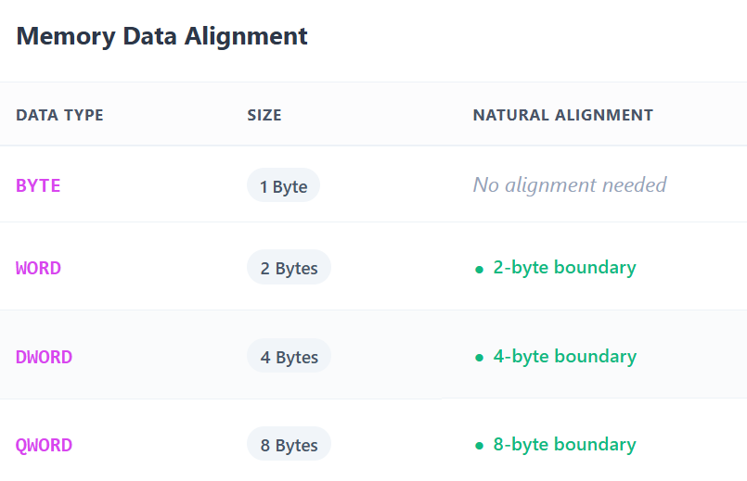

**Floating-Point Alignment**

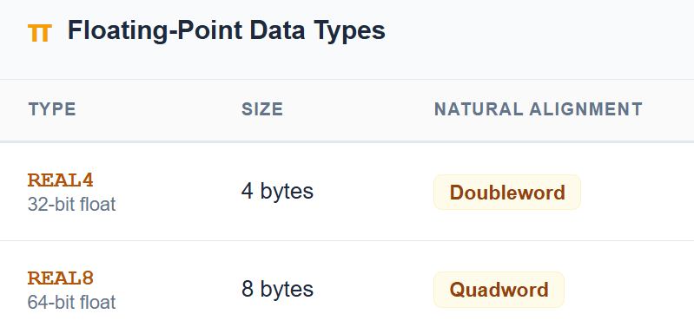

**Structure and Union Alignment**

* **Structures**
  + Aligned to the **largest alignment requirement** of any member
* **Unions**
  + Aligned to the **alignment of the first member**

The assembler automatically calculates padding unless explicitly overridden.

3. Why Alignment Matters

**Performance Impact**

* Aligned data:
  + Can be fetched in a **single memory access**
* Unaligned data:
  + May require **multiple memory reads**
  + Can cause CPU penalties or microcode fixes

**Practical Impact -** Small performance loss for single variables

**Large performance degradation** when:

* Iterating over arrays of structures
* Processing large datasets

4. Automatic vs Manual Alignment

**Automatic Alignment (Default)**

* MASM aligns:
  + Variables
  + Structure fields
* Based on data type requirements
* Usually sufficient for most programs

**Manual Alignment (When Needed)**

* Required when:
  + Mixing different-sized fields
  + Matching external data formats
  + Optimizing critical data paths

5. ALIGN Directive

**Purpose:** The ALIGN directive forces the **next variable or field** to start at a specific boundary.

Syntax:

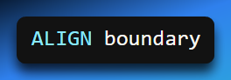

Where boundary can be:

* BYTE
* WORD
* DWORD
* QWORD

6. Aligning Standalone Variables

Example

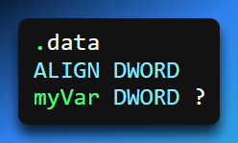

Explanation

* Ensures myVar starts at a **4-byte boundary**
* Prevents accidental misalignment due to previous data

7. Aligning Structure Fields

Problem Without Alignment - Fields may start at suboptimal addresses depending on preceding fields’ sizes.

Correctly Aligned Structure Example:

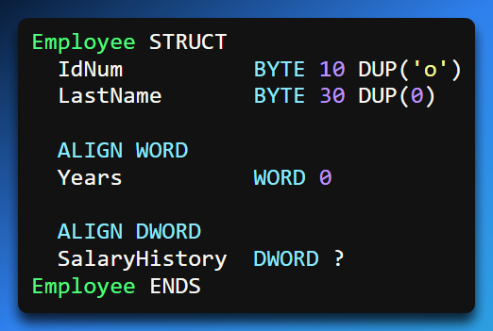

8. How Padding Works (Memory Layout)

Field Sizes & Offsets

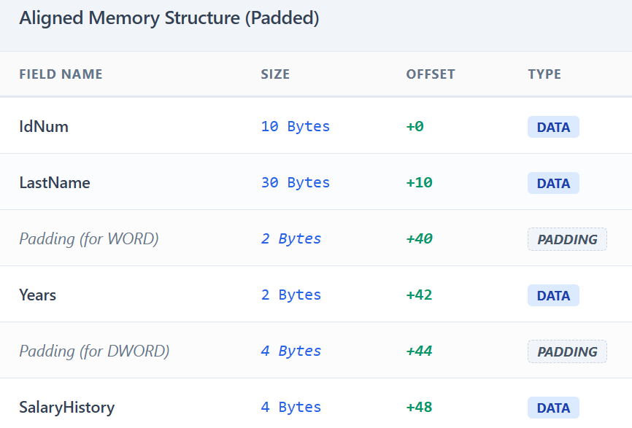

Total Structure Size:

* **52 bytes**
* Rounded up to alignment requirement if used in arrays

9. Visual Memory Layout (Suggested Diagram)

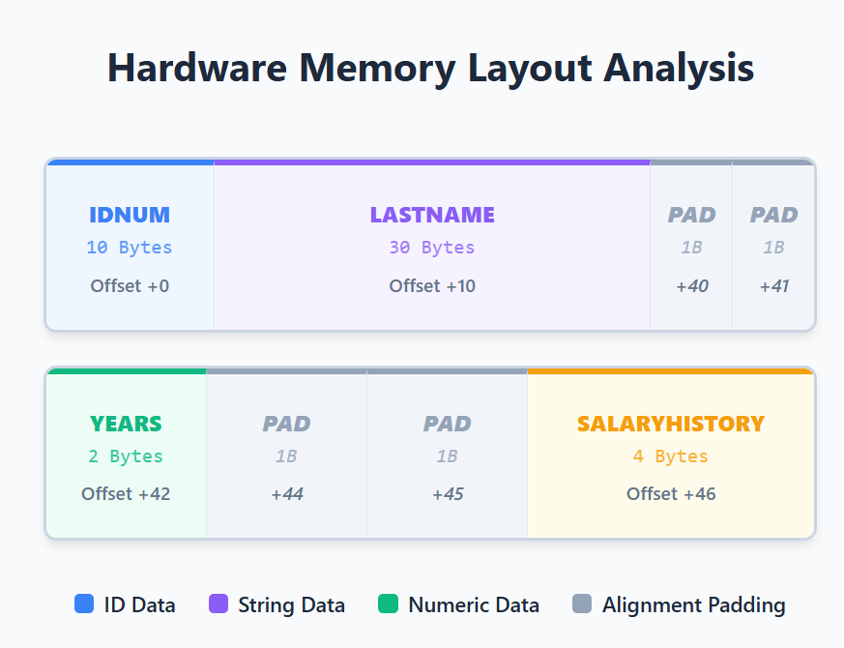

This shows how alignment introduces **padding bytes** to meet boundaries.

10. Why Structure Alignment Is Critical

* Affects:
  + Access speed
  + Cache efficiency
  + SIMD operations
* Especially important for:
  + Arrays of structures
  + Repeated memory access loops

11. Common Mistakes

* Assuming alignment is based on **field order**, not size
* Forgetting that padding bytes consume memory
* Manually hardcoding offsets instead of using field names
* Overusing ALIGN when the assembler already handles it

12. Key Takeaways

* Each data type has a **natural alignment**
* Structures align to their **largest field**
* Unaligned memory access hurts performance
* ALIGN lets you explicitly control field placement
* Always let the assembler compute offsets when possible

INDIRECT AND INDEXED OPERANDS STRUCTS

Indirect Operands

Indirect and Indexed Operands with Structures (x86 / MASM)

When working with **structures and arrays of structures**, direct addressing (StructVar.Field) is often not flexible enough.

Instead, assembly provides **indirect** and **indexed** operands that allow you to:

* Access structure members using registers
* Traverse arrays of structures
* Write loops and dynamic memory access code

What Is an Indirect Operand?

An **indirect operand** accesses memory **through a register** that holds an address.

* The register contains the **base address**
* The instruction dereferences that register
* Commonly used when:
  + Passing structure addresses to procedures
  + Accessing dynamically selected structures

PTR Operator (Why It Is Needed)

MASM requires **type information** when dereferencing memory through registers.

The PTR operator:

* Tells the assembler **what data type** the memory represents
* Allows access to structure members using dot notation

Syntax

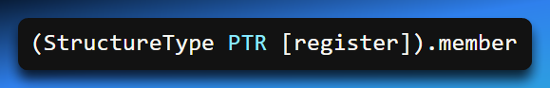

Example: Accessing a Structure via Indirection



Step-by-Step Explanation

1. OFFSET worker loads the address of the structure into ESI
2. [ESI] dereferences that address
3. Employee PTR tells MASM the memory layout
4. .Years accesses the correct offset inside the structure

Without PTR, MASM does not know how to interpret [esi]

2. Indexed Operands (Register + Offset Addressing)

**What Is an Indexed Operand?**

An **indexed operand** accesses memory using:

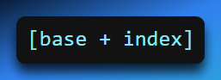

This is especially useful for **arrays of structures**.

**Typical Use Case**

* Base address → start of the array
* Index register → offset to a specific element
* Structure type → defines field offsets

3. Arrays of Structures

**Declaring an Array of Structures**

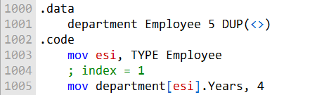

* Creates an array of 5 Employee structures
* Each element is placed contiguously in memory

4. Accessing an Array Element Using Indexing

**Correct Concept**

To access element i:

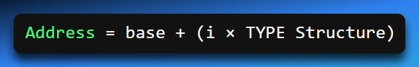

Corrected Example (Fixing 2022 Notes)

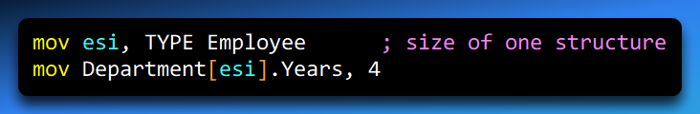

⚠ **Important Correction:**

* This accesses the **second element**, because:
  + esi = TYPE Employee
  + Offset = 1 × structure size

The original notes incorrectly implied esi held an index — it actually holds a **byte offset**.

**Preferred & Clearer Form**

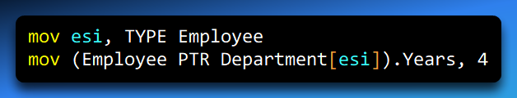

This ensures:

* Correct type interpretation
* Safe member access

5. Indirect + Indexed Addressing Combined

This is the **most common pattern** when looping through arrays of structures.

6. Looping Through an Array of Structures (Full Example)

Code:

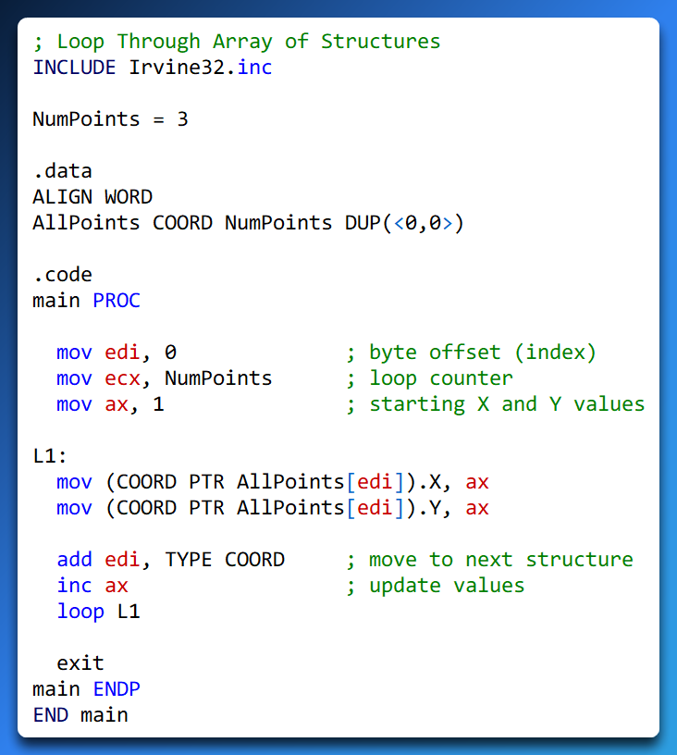

7. How This Loop Works (Step-by-Step)

**Initialization**

* EDI = 0 → start of the array
* ECX = NumPoints → loop count
* AX = 1 → initial coordinate value

**Inside the Loop**

Access current structure:

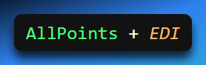

Write to X field

Write to Y field

Advance to next element:



1. Increment coordinate value
2. Loop until ECX = 0

8. Memory Layout Visualization (Recommended)

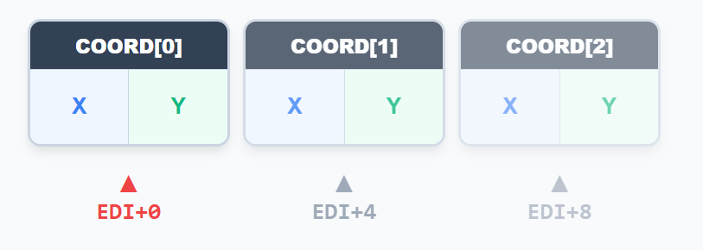

After each iteration:

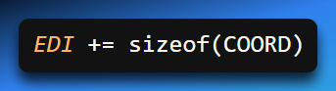

9. Common Pitfalls (Very Exam-Relevant)

* Treating index registers as **element numbers**, not byte offsets
* Forgetting to multiply index by TYPE Structure
* Omitting PTR when dereferencing registers
* Using displacement values instead of symbolic field names

10. Key Differences: Indirect vs Indexed

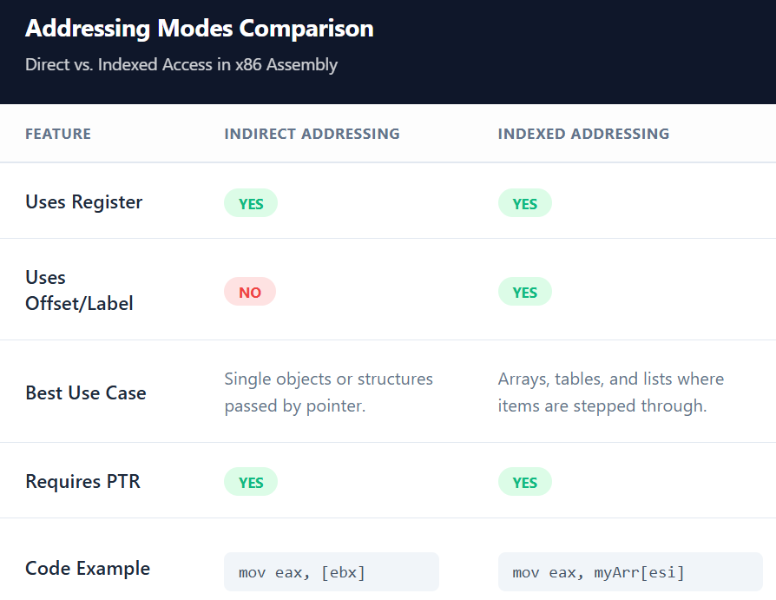

11. Key Takeaways

* **Indirect operands** use registers to hold structure addresses
* **Indexed operands** use offsets to access array elements
* PTR is mandatory for structure member access via registers
* Index registers always represent **byte offsets**
* TYPE Structure is critical for safe iteration

PERFORMANCE OF ALIGNED AND MISALIGNED STRUCTS

**Aligned structure members** are accessed by the CPU **more efficiently** than misaligned members.

When data is **properly aligned**, the CPU can access it using **fewer instructions and memory cycles**.

**Misaligned structure members** may require the CPU to perform **multiple memory accesses** to read or write a single data item.

The **performance impact** of misalignment depends on:

* The **CPU architecture**
* The **data size** of the member
* The **layout of the structure**

On some architectures, misaligned access causes a **performance penalty**, while on others it may even cause a **hardware exception**.

In general, **misaligned structures reduce execution speed** compared to aligned structures.

Performance testing code can be used to **compare access times** between aligned and misaligned structure members.

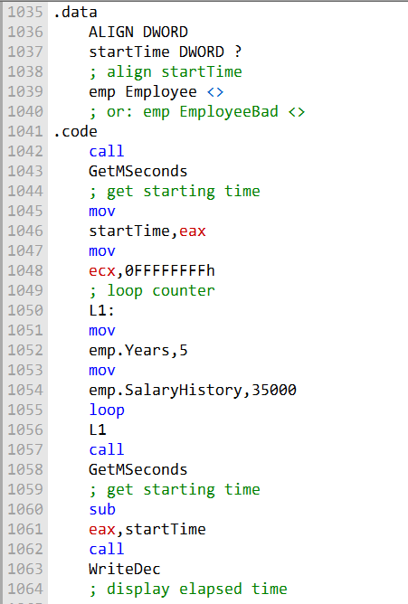

Example: Performance Impact of Aligned vs. Misaligned Structures

* The code example:
  + Retrieves the **system time**.
  + Executes a **loop that accesses structure fields**.
  + Calculates the **elapsed time**.
* The variable emp can be declared as either:
  + **Employee** → aligned structure
  + **EmployeeBad** → misaligned structure
* Observed results:
  + Using **Employee**: elapsed time = **6141 ms**
  + Using **EmployeeBad**: elapsed time = **6203 ms**
  + **Difference** = 62 ms (small but measurable)
* Interpretation:
  + Even **minor misalignment** can **negatively affect performance**.
  + Impact depends on **CPU architecture** and **structure layout**.
  + On some systems, misalignment can cause a **larger performance penalty**.
* **Conclusion / Best Practice:**
  + Always **align structure members** to their natural boundaries.
  + Proper alignment ensures **efficient CPU access** and **better performance**.

Example: Displaying the System Time

The following is a step-by-step explanation of the program ShowTime.asm in depth:

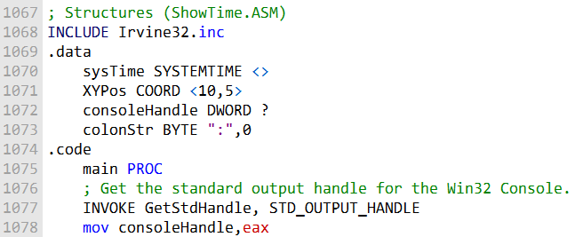

* The **first part of the program** defines the **data structures** that will be used.
* sysTime → **SYSTEMTIME** structure, used to **store the current system time**.
* XYPos → **COORD** structure, used to **store the cursor position** in the console.
* consoleHandle → **DWORD** variable, used to **store the handle to the standard output**.
* **GetStdHandle** function: retrieves the **handle to the standard output**.
* The **console handle** is then used by:
  + **SetConsoleCursorPosition** → positions the cursor in the console.
  + **WriteString** → writes data to the console at the current cursor position.

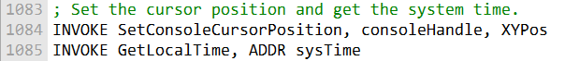

Setting Cursor Position and Retrieving System Time

The program **sets the cursor position** and **retrieves the system time**.

**SetConsoleCursorPosition** function:

* Sets the **cursor position** in the console to the specified coordinates (XYPos).

**GetLocalTime** function:

* Retrieves the **current system time** and stores it in the sysTime structure.

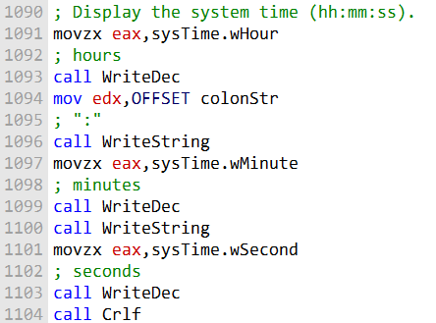

Displaying System Time on the Console

* The program **displays the system time** to the console.
* **WriteDec** function:
  + Writes a **decimal number** to the console (e.g., hours, minutes, seconds).
* **WriteString** function:
  + Writes a **string** to the console (e.g., labels like “Hour: ”).
* **Crlf** function:
  + Writes a **carriage return and line feed** to move the cursor to the next line.

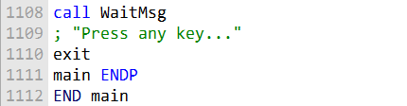

Displaying a Message and Waiting for User Input

WaitMsg function:

* Displays a **message** to the console.
* **Waits for the user** to press a key before continuing.

Conclusion

The ShowTime.asm program demonstrates how to use structures in assembly language.

Structures allow grouping of related data, improving:

* Code readability
* Maintainability

Proper use of structures, along with **alignment considerations**, ensures **efficient CPU access** and **better performance**.

STRUCTURES CONTAINING STRUCTURES

A **nested structure** occurs when a **structure contains instances of other structures**.

This allows grouping of **complex or related data** within a larger structure.

**Example:** Rectangle structure can have two fields:

* upperLeft → a **COORD** structure
* lowerRight → a **COORD** structure

Nested structures help in organizing data hierarchically and make code more readable and maintainable.

Accessing fields in a nested structure uses the syntax:

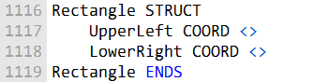

Or

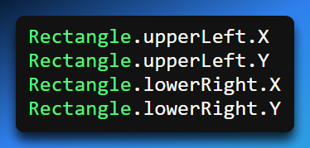

Rectangle Structure with Nested COORDs

A Rectangle structure **contains two COORD structures**:

* **UpperLeft** → represents the upper-left corner of the rectangle
* **LowerRight** → represents the lower-right corner of the rectangle

Rectangle variables can be **declared in different ways**:

* **Without overrides** → all fields use default/uninitialized values
* **With overrides** → individual COORD fields can be initialized with specific values

Examples of declarations:

* rect1 RECTANGLE <> → default/uninitialized
* rect2 RECTANGLE <UpperLeft <10, 20>, LowerRight <50, 80>> → all fields initialized
* rect3 RECTANGLE <UpperLeft <5, 15>, LowerRight <>> → partially initialized

Nested field access uses the syntax:

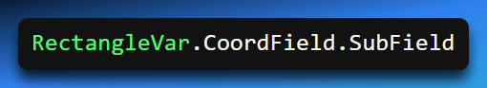

Or

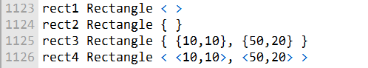

This structure allows **grouping related coordinate data** in a readable and maintainable way.

Declaring and Accessing Nested Structure Variables

**Rectangle variables** can be declared in multiple ways:

* rect1, rect2 → created with default values for UpperLeft and LowerRight.
* rect3 → created with specified values for UpperLeft and LowerRight.
* rect4 → alternative syntax for specifying field values.

**Accessing fields** of a structure uses **dot notation**:

* Example: move 10 to the **X coordinate** of rect1’s UpperLeft:

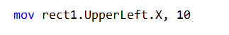

Accessing fields via indirect addressing

Example: move 10 to the **Y coordinate** of UpperLeft in a structure pointed to by esi:



**Using OFFSET operator** to get pointers to structure fields (including nested fields):

Example: move 50 to the **X coordinate** of LowerRight in rect2:



* Dot notation works for **direct variable access**.
* Indirect addressing + ptr allows **pointer-based access**.
* OFFSET operator returns **memory address of a field**, useful for **nested structures**.

Example program

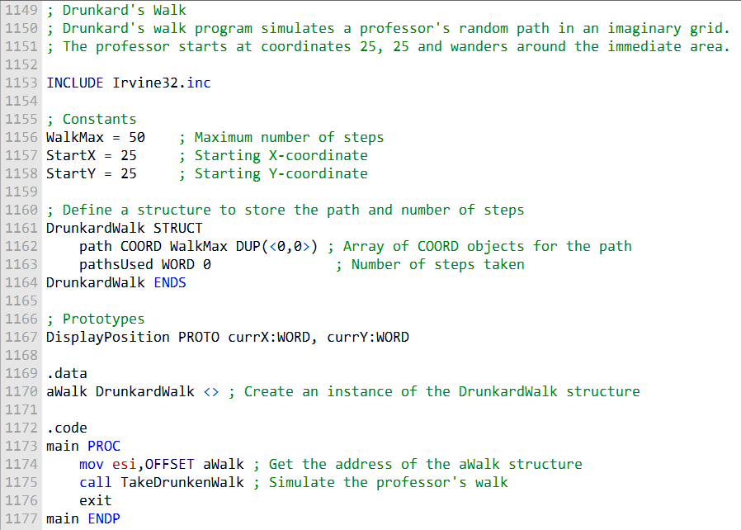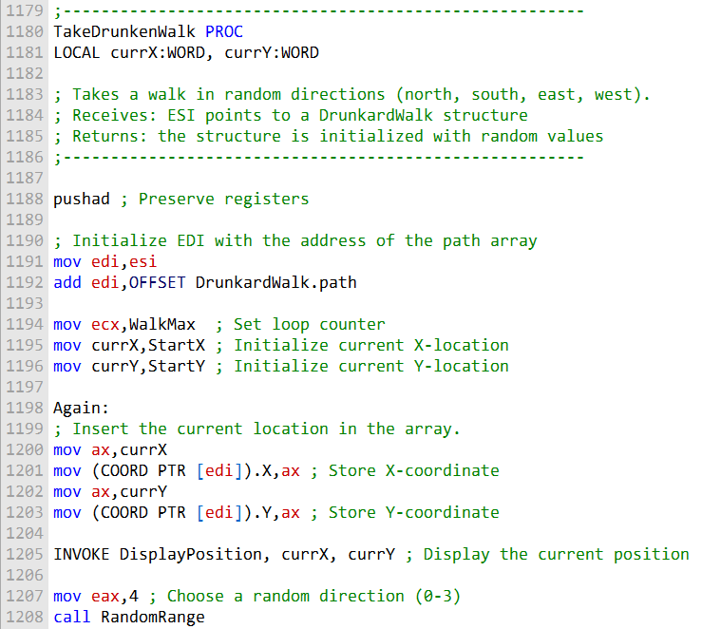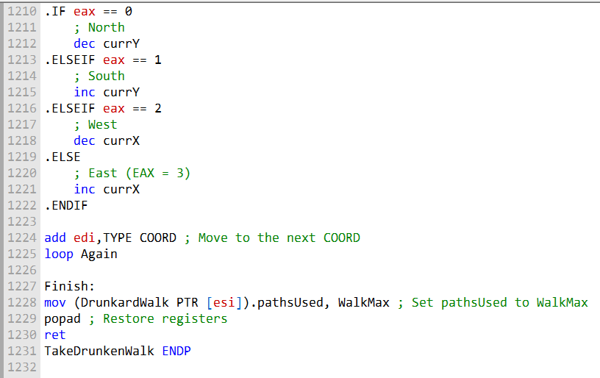

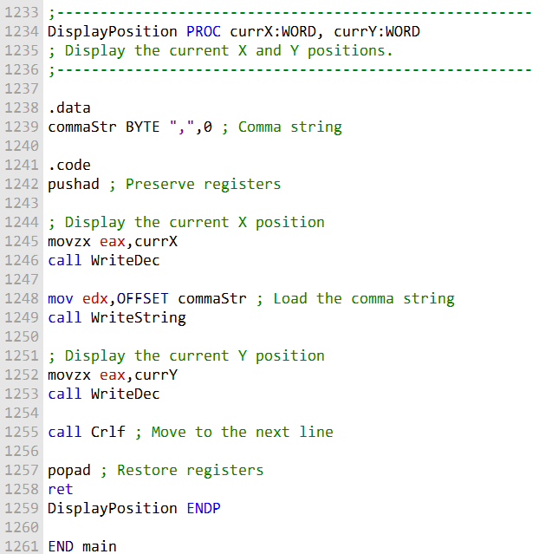

Drunkard’s Walk Program (Simulates a Professor’s Random Walk)

1. Include Directives

INCLUDE Irvine32.inc

Provides **console I/O** functions and other utilities.

2. Constants

WalkMax → Maximum number of steps in the walk.

StartX, StartY → Starting coordinates of the professor.

3. Structure Definition

**DrunkardWalk STRUCT … ENDS**

* path → Array of **COORD** objects to store the professor’s path.
* pathsUsed → WORD to track the **number of steps taken**.

4. Function Prototypes

* DisplayPosition → Displays the professor’s **current X and Y coordinates**.

5. Data Section (.data)

Defines program data, including:

aWalk → An **instance of the DrunkardWalk structure**.

6. Code Section (.code)

**Main Procedure**

* Entry point of the program.
* Initializes ESI with the address of aWalk.
* Calls TakeDrunkenWalk to simulate the professor’s walk.

**TakeDrunkenWalk Procedure**

Simulates the **random walk**:

* Initializes local variables currX and currY to **starting coordinates**.
* Loop runs until **WalkMax** steps are completed:
  + Inserts current coordinates into path array.
  + Calls DisplayPosition to show current position.
  + Randomly selects **next direction** (north, south, east, west).
* Updates pathsUsed in aWalk to indicate the **total steps taken**.

**DisplayPosition Procedure**

* Displays **X and Y coordinates** with proper formatting:
  + WriteDec → prints numbers.
  + WriteString → prints commas or text.
  + Crlf → moves cursor to **next line**.

7. Program Termination

* Walk is complete.
* END main → Marks **end of the program**.

8. Short note:

* Uses a **structure** to manage data related to the professor’s walk.
* Tracks the **path** and **number of steps**.
* Randomly selects steps until the **maximum is reached**.
* Demonstrates **structure usage, arrays, loops, and console I/O** in assembly.

UNIONS IN ASSEMBLY

A **union** is a user-defined data type that **groups multiple fields at the same memory offset**.

* **Key property:** Only **one field exists at a time** in memory; all fields share the same location.
* **Size of a union:** Determined by the **largest field** it contains.
* **Declaration:** Use the **UNION** and **ENDS** directives.

Example of a union declaration:

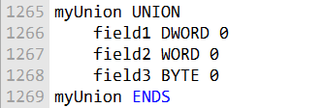

Field initialization rules:

* Each field in a union can have **only one initializer**.
* Fields follow the same rules as structures, but since all share the same memory, initializing one affects the union as a whole.

Nesting Unions in Structures

You can include a union **inside a structure** to combine flexibility and organization.

Two main ways to nest a union:

Declare the union directly inside the structure

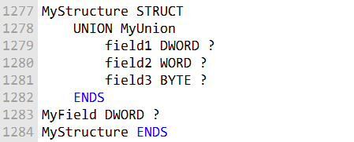

Use the union's name in a declaration inside the structure/ Declare a union separately and include it as a field in the structure.

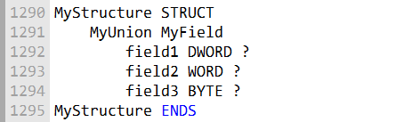

Declaring and Using Union Variables

Declaring a union variable is similar to declaring a structure variable.

However, you can only have one initializer:



To use a specific field of a union variable, you supply the field's name. For example:

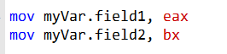

Unions Can Contain Structures

**Unions can contain structures** as their fields.

This allows a single memory location to represent **different types of structured data** depending on the situation.

**Example: KEY_EVENT_RECORD (Windows API)**

* The structure contains a union named **uChar**.
* The union can store:
  + A **Unicode character**
  + An **ASCII character**
* Depending on the **keyboard event type**, the program uses the appropriate field.



Advantages of combining unions and structures in assembly:

* Efficient **memory usage**: multiple types share the same memory space.
* Flexible handling of **alternative data formats**.
* Makes code **more organized and readable** when dealing with complex data like input events or records.

Key point:

* Unions allow **storing data of different sizes in the same memory space**, while structures help **group related fields together**.
* Together, they provide a **powerful way to organize complex data** in assembly language programs.



MACROS IN ASSEMBLY

What is a Macro?

* A **macro** is a named block of assembly statements.
* It can be **invoked multiple times** in a program.
* When called, the macro’s **code is inserted directly** where it’s invoked (**inline expansion**).
* No actual CALL instruction is used — the code is just copied into place.

Placement of Macros:

* Usually defined at the **beginning of the source code**.
* Can also be placed in a **separate file** and included via the INCLUDE directive.

How Macros Work:

* Expanded during the **assembler’s preprocessing step**.
* Every invocation is replaced with a **copy of the macro’s code**.
* If a macro is defined but never called, its code **does not appear** in the compiled program.

Defining Macros:

* Use the MACRO and ENDM directives.
* Example syntax:

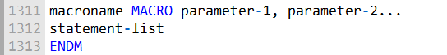

Or

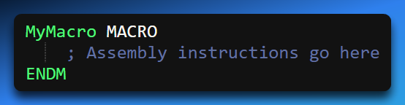

Macros with Parameters in Assembly

What are Parameters?

* Named placeholders for values passed to a macro.
* Can be text, integers, variable names, or other values.
* The preprocessor treats them as text; no type checking occurs at macro expansion.
* Type checking happens during assembly.

Example: mPutchar Macro

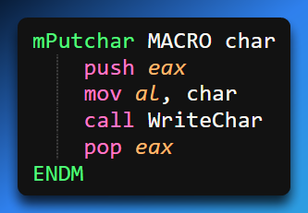

Takes a **single parameter** char.

* Temporarily saves eax to preserve its value.
* Moves char into AL and calls WriteChar to display it.
* Restores eax after the call.

How it Works:

When invoked, the **macro code is inserted inline**, replacing the macro call.

Example:

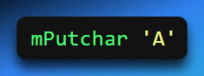

Expands into the four assembly statements above, displaying 'A' on the console.

Key Advantages of Parameterized Macros:

* Avoids repetitive coding.
* Makes programs **more readable and maintainable**.
* **Flexible and reusable** — can handle different arguments for different situations.

Macros with parameters are a **powerful tool** for modular assembly code.

They let you **reuse code efficiently** without function call overhead.

Using **mPutchar** used for printing a single character to the console:

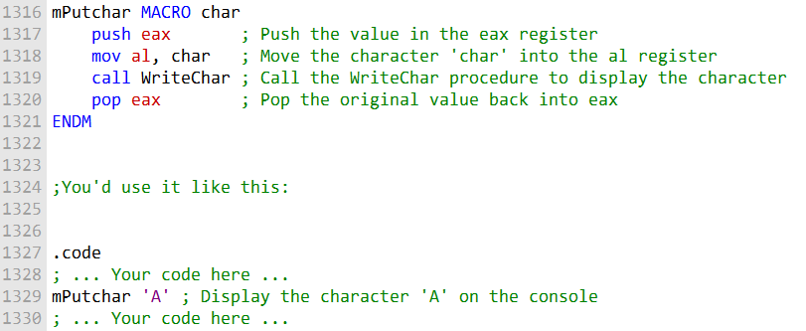

Invoking (Using) a Macro

* To use a macro, just write its **name** in your program.
* You can also give it **arguments** (extra information it needs).
* The arguments you give replace the placeholders inside the macro.
* The order matters: the first argument goes to the first placeholder, the second to the second, and so on.
* If you give **too many arguments**, the assembler warns you.
* If you give **too few arguments**, the missing ones stay empty.
* When the program runs, the macro is expanded into the actual instructions it represents.

Debugging Macros

Macros can be tricky to debug because they expand into hidden code.

To check what’s really happening:

* Look at the **listing file (.LST)** after assembling. It shows how macros were expanded.
* In tools like **Visual Studio Community**(not VSCode), you can open the **disassembly view** to see the actual machine code created from the macro.

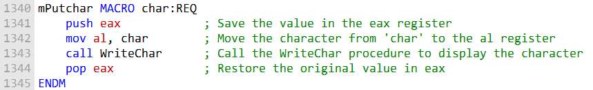

Extra Features of Macros

* You can mark some arguments as **required** using the REQ qualifier.
* If you forget to provide a required argument, the assembler gives an error.
* You can hide comments inside macros by using **double semicolons (;;)**.
* This way, notes you write inside the macro won’t appear in the expanded code.

Summary

* Think of macros as **predefined mini-functions** in assembly.
* You call them by name, give them arguments, and they expand into the instructions you need.
* They save time, reduce repetition, and make your code easier to manage.
* But remember: debugging can be harder, so always check how they expand.

ECHO AND LOCAL DIRECTIVES

**📢** The ECHO Directive in Assembly

What is ECHO?

* The **ECHO directive** is a special instruction used during assembly (when your source code is being converted into machine code).
* It doesn’t affect the program’s execution at runtime. Instead, it **prints a message to the assembler’s output window or console while assembling**.
* Think of it as a way to leave “breadcrumbs” or **status messages** for yourself or other programmers.

Why Use ECHO?

* **Debugging aid**: Helps you see when certain macros are being expanded.
* **Informative messages**: Lets you print reminders or notes during assembly.
* **Tracking flow**: Useful when your program has many macros—you can confirm which ones are being expanded and in what order.

Example Macro with ECHO

Here’s the macro explained line by line:

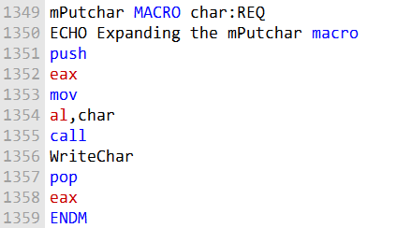

mPutchar MACRO char: REQ

* Defines a macro named mPutchar.
* It takes one required parameter: char.
* If you forget to provide char, the assembler will throw an error.

ECHO Expanding the mPutchar macro

* When the assembler reaches this line, it prints the message: *“Expanding the mPutchar macro”*
* This happens **during assembly**, not when the program runs.
* It’s like a debug log telling you: “Hey, I’m expanding this macro right now.”

push eax

* Saves the current value of the eax register onto the stack.
* This prevents overwriting whatever was in eax before.

mov al, char

* Moves the character you passed into the macro into the al register (the lower 8 bits of eax).
* Example: If you called mPutchar 'A', then 'A' is placed into al.

call WriteChar

* Calls a procedure named WriteChar.
* This procedure is responsible for displaying the character stored in al onto the console.

pop eax

* Restores the original value of eax from the stack.
* This ensures the macro doesn’t accidentally change eax permanently.

**ENDM** - Marks the end of the macro definition.

What Happens When You Use It

Suppose you write: **mPutchar 'A'**

**During assembly:**

* The assembler prints: *“Expanding the mPutchar macro”* (thanks to ECHO).
* Then it replaces the macro call with the actual instructions (push eax, mov al, 'A', call WriteChar, pop eax).

**At runtime:**

* The program executes those instructions and displays the character 'A' on the console.

**So, you get two layers of feedback:**

* One during assembly (ECHO message).
* One during execution (the character output).

ECHO = Assembly-time message tool



* It’s like a **debugging print statement**, but for the assembler, not the running program.
* Helps track macro expansions, confirm flow, and leave notes.
* Doesn’t affect the final machine code—only what you see while assembling.

LOCAL Directive in Macros

Problem with Labels in Macros:

* Macros often contain **labels** for jumps, loops, or internal references.
* If a macro is **invoked multiple times**, the **same label is redefined** each time.
* Redefining labels causes **assembler errors** due to duplicate names.

Solution – LOCAL Directive:

* Use the **LOCAL** directive to declare labels inside a macro.
* The assembler **generates a unique name** for each invocation of the macro.
* This allows **safe reuse of macros** with internal labels without conflicts.

Example:

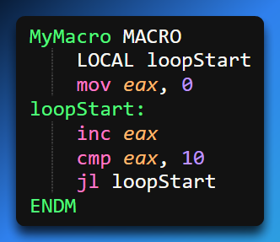

Or

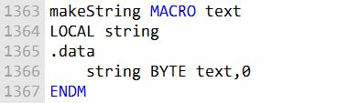

* loopStart is **local to the macro invocation**.
* Each time MyMacro is called, a **unique loopStart label** is created.
* Avoids **duplicate label errors** in programs with multiple macro calls.

Using LOCAL in Macros - Purpose of LOCAL:

* Prevents **label redefinition errors** when a macro is invoked multiple times.
* Ensures that **each macro call gets unique labels or variables**.
* Makes macros **reusable, modular, and safer**.

**How It Works:** Place the **LOCAL** keyword before a label or variable inside the macro:

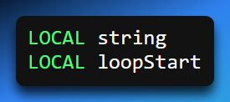

The assembler generates a **unique name** for each invocation of the macro.

Example – makeString Macro:

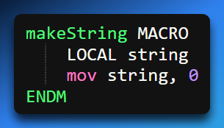

If makeString is called multiple times, each string variable is **unique**.

Avoids conflicts or overwriting memory in the program.

What Labels Can Be Local:

* **Code labels** (for jumps or loops)
* **Data labels/variables**

Interaction with ECHO:

* **ECHO** can be used to print **assembly-time messages** for debugging.
* **LOCAL** prevents label collisions, making macro debugging and tracing easier.

Key Benefits of Using LOCAL:

* Makes macros **reusable and modular**
* Ensures **safe internal jumps and loop labels**
* Simplifies **macro maintenance in large assembly programs**



Macros Containing Code and Data

* In assembly language, **macros are not limited to just instructions**.
* A macro can include both **executable code** (instructions like mov, add, jmp) and **data declarations** (variables, arrays, or constants).
* This allows you to create a **self-contained reusable block** that can initialize data and perform operations on it whenever the macro is invoked.
* For example, a macro could define a **temporary variable** and immediately perform calculations or manipulate that variable as part of its code.
* This feature makes macros extremely **flexible**, enabling both **modular code design** and **automatic data setup** without having to write separate variable declarations elsewhere.

Example: mWrite Macro

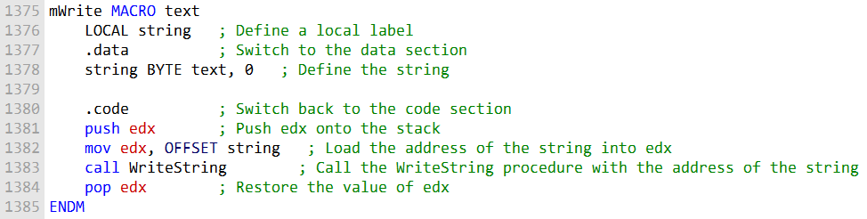

Defines a reusable **function-like macro** that displays a string on the console.

Makes it easy to display messages **without writing repetitive code**.

Takes a single parameter: text — the string to display.



**Local Label:**

* Defines a **local label** (e.g., string) using the LOCAL directive.
* This label uniquely identifies the string in the **.data section** for each macro invocation.

**Data Declaration:**

* The string parameter (text) is associated with the local label in memory.

**Code Section:**

* Pushes the **address of the string** onto the stack.
* Calls the **WriteString procedure** to display the string on the console.
* Pops the address off the stack to **restore the previous state**.

**Benefits:**

* Each invocation gets its **own unique string label**.
* Avoids **label conflicts** if the macro is called multiple times.
* Allows you to **display strings easily** without manually declaring variables or writing repeated code.
* Makes macros **modular, reusable, and easier to maintain**.

**Example Usage:**

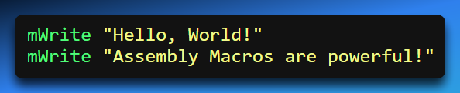

* Each call **expands inline** into code that pushes, calls WriteString, and pops.
* Each string gets a **unique memory label**, thanks to LOCAL.



Nested Macros in Assembly

Definition:

* A nested macro is a macro that is called from within another macro.
* When the assembler encounters a call to a nested macro, it expands the code in place.
* Parameters from the enclosing macro are passed directly to the nested macro.

Example – mWrite1n Macro:

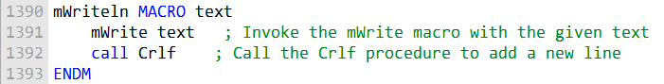

Simplifies writing a line of text by combining:

* mWrite (displays the string)
* Crlf (adds a newline)

**Macro Invocation Example:**

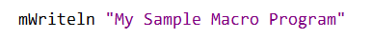

When the assembler expands this statement, it will first expand the mWriteln() macro. This will result in the following code:

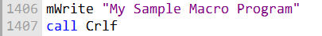

This code will then be expanded to the following instructions:

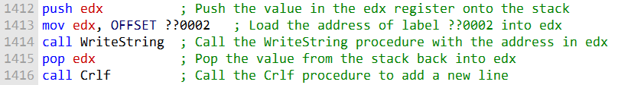

Then the mWrite macro expands to assembly instructions:

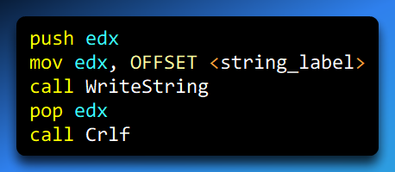

How It Works:

1. **Pushes register** (edx) to save previous value.
2. **Loads string address** into the register.
3. **Calls WriteString** to display the text.
4. **Pops register** to restore original value.
5. **Calls Crlf** to append a newline.

Tips for Creating Effective Macros

* **Keep macros short and simple:**
  + Easier to **read, understand, and maintain**.
* **Use a modular approach:**
  + Break **complex operations into smaller macros**.
  + Increases **reusability and flexibility**.
* **Use LOCAL directive:**
  + Prevents **label redefinition errors** when macros are called multiple times.
* **Document macros clearly:**
  + Helps other programmers **understand usage and purpose**.
* **Key Takeaway:**
  + Macros are a **powerful tool** for simplifying repetitive code.
  + Proper use ensures **clean, maintainable, and reusable assembly programs**.

Irvine32/64 library and Macros:

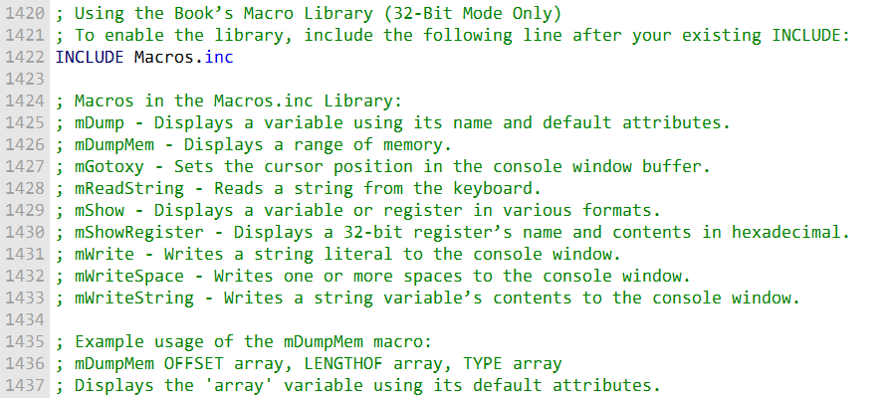

Macros.inc Library – Overview

* **Purpose:**
  + Provides a collection of **predefined macros** that simplify common assembly tasks.
  + Helps programmers **avoid repetitive code** and work more efficiently.
* **Typical Macros Included:**
  + **Display variables** on the console
  + **Manipulate cursor positions**
  + **Read input from the keyboard**
  + **Dump memory blocks**
  + And more—ready-to-use, modular macros for common tasks
* **How to Use:**
  + Include the library in your program:

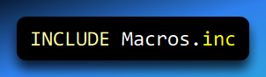

mDumpMem Macro

Displays a **block of memory** in the console window in a readable format.

Useful for **debugging**, inspecting memory, or tracking variable contents.

**Parameters:**

* **Memory offset** – starting location of the memory block to display
* **Number of items** – how many items to show
* **Size of each item** – e.g., byte (1), word (2), or double word (4)

**How It Works:**

* Internally calls the **DumpMem procedure** from the library.
* Maps the macro parameters to **registers used by DumpMem**:
  + ESI → memory offset
  + ECX → number of items
  + EBX → size of each item

**Example Usage:**

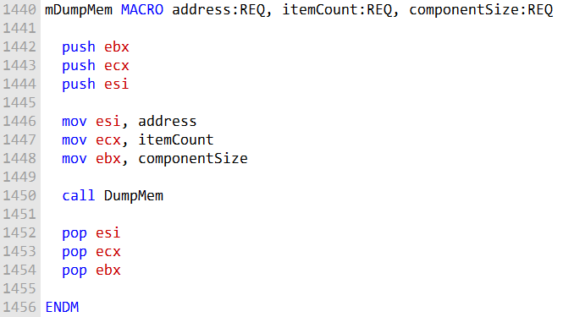

Or

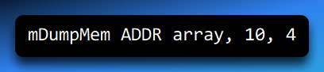

Displays **10 DWORDs** starting from array in the console.

Benefits

* Provides a **quick, readable memory dump** without writing low-level assembly instructions.
* Makes **debugging and memory inspection** much easier.
* Avoids the risk of **register corruption**, as it internally manages EBX, ECX, and ESI.

Purpose

* Displays a **memory block** in the console using the **DumpMem procedure**.
* Shows both the **memory offsets** and **hex values** of the data.
* The output format depends on the **size of each memory component**.

Parameters

1. **address** – Offset of the memory block to dump.
2. **itemCount** – Number of items to display.
3. **componentSize** – Size in bytes of each component (1 = byte, 2 = word, 4 = DWORD).

How It Works

* Maps the macro arguments to **registers internally** for the DumpMem procedure:
  + ESI ← address
  + ECX ← itemCount
  + EBX ← componentSize
* Displays a **formatted memory dump**, showing the **offset and hex values** of each component.
* Avoids modifying registers in your main program, so your code remains safe.

Example Usage

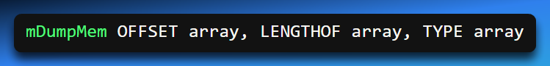

Displays the **contents of array**:

* OFFSET array → starting address
* LENGTHOF array → number of items
* TYPE array → size of each element (BYTE, WORD, DWORD)

Produces a **console-friendly hex dump** that helps you inspect the memory block easily.

mDumpMem is a **convenient, reusable macro** for debugging.

Automatically formats memory, handles registers safely, and saves you from writing repetitive code for memory inspection.

mDump macro

The mDump macro displays the memory address and hexadecimal contents of a variable.

* **varName** – The name of the variable to dump.
* **useLabel** *(optional)* – A label to display alongside the output. If provided and non-blank, the macro prints the variable name.

Behavior:

* The output size and format automatically match the variable’s declared type.
* Useful for debugging or inspecting variable contents at runtime.

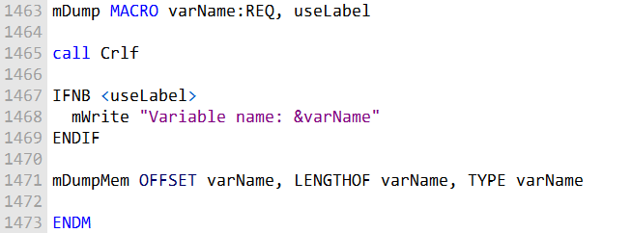

* The &varName substitution operator inserts the actual variable name into the output string.
* IFNB checks whether useLabel was passed a non-blank value.
* mDumpMem is called to print the hexadecimal dump using the variable’s attributes.

**Summary:**

The mDump macro provides a simple and convenient way to inspect variables for debugging, automatically formatting output based on the variable’s type and optionally labeling it for clarity.

**mDump** helps inspect variable values, sometimes you need precise control of the console display. That’s where **mGotoxy** comes in.

mGotoxy Macro

The mGotoxy macro positions the cursor at a specified location in the console window.

**Parameters:**

* Two **BYTE** values representing the **X** (column) and **Y** (row) coordinates.

**Usage Notes:**

* Avoid passing **DH** and **DL** directly to prevent register conflicts.
* Useful for creating organized console output, menus, or formatted debugging displays.

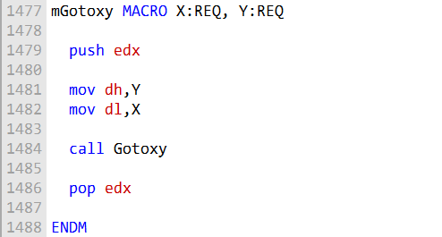

**Register conflict example:**

If DH and DL are passed as arguments, the expanded code would be:

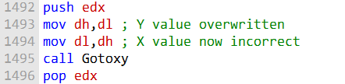

DH is overwritten by DL before it can be copied to DL.

So the macro documentation warns not to pass DH/DL to avoid this problem.

**In summary,** mGotoxy sets the cursor position, but care must be taken with register arguments to prevent conflicts. The macro code/docs make this clear.

mReadString Macro

The mReadString macro reads user input from the keyboard and stores it in a specified buffer.

**Parameter:**

* **varName** – The name of the buffer where the input string will be stored.

**Behavior and Notes:**

* Safely reads a string from the keyboard and stores it in the buffer.
* Internally avoids using **ECX** and **EDX** registers to prevent conflicts with other code.
* Useful for interactive console programs that require text input.

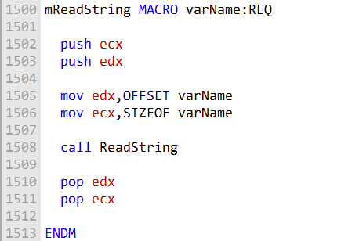

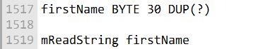

This would call ReadString to input a string from the keyboard into the firstName buffer.

**Summary:**  
mReadString provides a simple, safe way to capture keyboard input into a variable without interfering with other registers, making it ideal for debugging or console-based user input.

mShow macro

The mShow macro displays the name and contents of a register or variable in one or more selectable formats. It is primarily used for debugging and inspecting values quickly.

**Parameters:**

1. **Register or variable name** – The target value to display.
2. **Format specifiers** *(optional)* – A string defining how the value should be displayed:
   * **H** – Hexadecimal
   * **D** – Decimal (unsigned by default)
   * **I** – Signed decimal
   * **B** – Binary
   * **N** – Newline

**Behavior:**

* Multiple format specifiers can be combined, e.g., "HDB" will display the value in hex, decimal, and binary.
* Multiple Ns can be included to insert extra line breaks.
* If no format is specified, the default is "HIN" (hexadecimal, signed decimal, newline).

**Example:**  
To display the contents of **AX** in multiple formats:

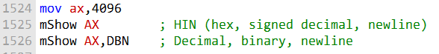

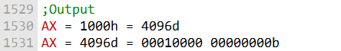

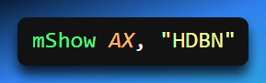

This will print AX’s value in hexadecimal, decimal, and binary, followed by a newline.

Display multiple registers on one line:

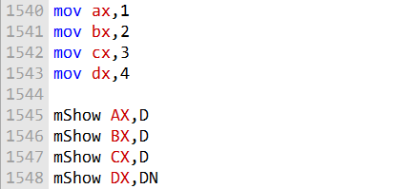



Display variable in decimal with newline:

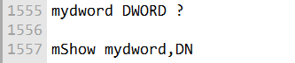

**Summary:**  
mShow provides a flexible, readable way to inspect registers or variables in multiple formats, making it an essential tool for debugging assembly programs.

mShowRegister macro

The mShowRegister macro displays a 32-bit register’s name and its hexadecimal value. It is designed for debugging and inspection of register contents.

**Parameters:**

1. **regName** – The name of the register to display (string).
2. **regValue** – The 32-bit value of the register.

**Example Output:**



**Implementation Details:**

* Declares a local string variable tempStr to hold the label.
* Pushes **EAX** and **EDX** to preserve registers used internally.
* Builds the label string by combining the register name and '='.
* Calls WriteString to display the label.
* Pops **EDX** to restore its original value.
* Moves the register value into **EAX**.
* Calls WriteHex to display the hexadecimal value.
* Pops **EAX** to restore its original value.

**Key Points:**

* Local variables prevent interference with the caller’s code.
* Register preservation avoids corruption of important registers.
* WriteString and WriteHex handle formatted output.
* Substitution operators ensure the correct regName and regValue are displayed.

**Summary:**  
mShowRegister encapsulates all the steps needed to display a register’s name and value. The caller only provides the name and value, making debugging simple and safe.

**Transition to mWriteSpace and mWriteString**

In addition to displaying variables and registers, sometimes you need to control console output directly. The next macros, mWriteSpace and mWriteString, handle formatted console output.

mWriteSpace Macro

* Writes one or more spaces to the console window.
* **Parameter (optional):** The number of spaces to write.
* **Default:** 1 space if no parameter is provided.

**Use Case:** Formatting output, aligning columns, or creating padding in the console.



**📝** mWriteString Macro

* The **mWriteString macro** is like a shortcut for printing text to the console.
* Instead of writing all the low-level instructions every time, you just call this macro with the name of a string variable.
* It makes your code cleaner and less repetitive.

**Parameter**

* The macro takes **one parameter**: the **name of the string variable** you want to display.
* Example: If you have a string called msg, you can call the macro with msg to print it.

**How It Works**

* The macro relies on **low-level routines** (like WriteString) that actually handle the printing.
* When you invoke the macro:
  1. It pushes the address of the string variable onto the stack.
  2. Calls the WriteString routine to display the text.
  3. Pops the address off the stack to restore the program’s state.
* This way, the macro acts like a wrapper around the printing routine.

**Use Cases**

* **Displaying messages**: Show instructions or prompts to the user.
* **Labels**: Print headings or identifiers in your program output.
* **Formatted text**: Align or organize console output neatly.
* **Debugging**: Print variable values or status messages while testing.

**Benefits**

* Saves time: No need to rewrite printing code.
* Cleaner code: Makes programs easier to read.
* Reusable: You can call it anywhere in your program.
* Safer: Reduces mistakes since the printing logic is centralized.

mWriteSpace Macro

The mWriteSpace macro writes one or more space characters to the console. It handles the details of preparing the string and calling the appropriate output routines.

**How it Works:**

1. Defines a **local label** named spaces in the .data section. This label points to a string of space characters.
2. Generates the code for the mWriteSpace() function:
   * Pushes the address of the spaces string onto the stack.
   * Calls the WriteString() function to display the spaces.
   * Pops the address from the stack to restore the original state.
3. If a numeric parameter is passed (e.g., mWriteSpace 5), the macro ensures that exactly that number of spaces is written.

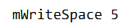

When the assembler expands this statement, it will first expand the mWriteSpace() macro. This will result in the following code:

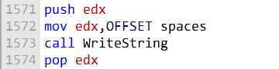

Macro expands to a call sequence. Low-level instructions executed internally:

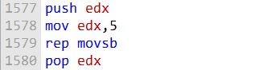

**Explanation:**

* rep movsb copies the specified number of bytes (spaces) from the source to the destination.
* The source (EDX) increments after each byte copied, as does the destination (console output).
* Pushing and popping EDX ensures registers used internally are preserved.

**Summary:**  
mWriteSpace provides a convenient and safe way to insert spaces into console output without manually writing loops or managing registers. You can specify the number of spaces, and the macro handles all underlying instructions for you.

mWriteString

The mWriteString macro writes the contents of a string variable to the console window. It abstracts the low-level instructions needed to pass the string to WriteString().

**Parameter:**

* **varName** – The name of the string variable to display.

**How it Works:**

1. Saves **EDX** on the stack to preserve the register, since WriteString() uses **EDX** to hold the string’s address.
2. Loads the address of the string variable into **EDX**.
3. Calls the WriteString() function to display the string.
4. Restores **EDX** from the stack.

**Example Usage:**

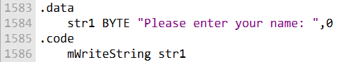

Expanded macro code:

When the assembler expands this statement, it will first expand the mWriteString() macro. This will result in the following code:

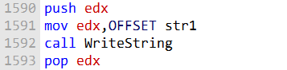

Instructions executed internally:

This code will then be expanded to the following instructions:

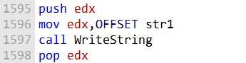

**Summary:**  
mWriteString simplifies console output by wrapping the WriteString() call, preserving registers, and avoiding repetitive code. Using this macro makes programs cleaner and more readable.

Wraps.asm

Demonstrates use of wrapper macros for common procedures, making code easier to write and maintain.

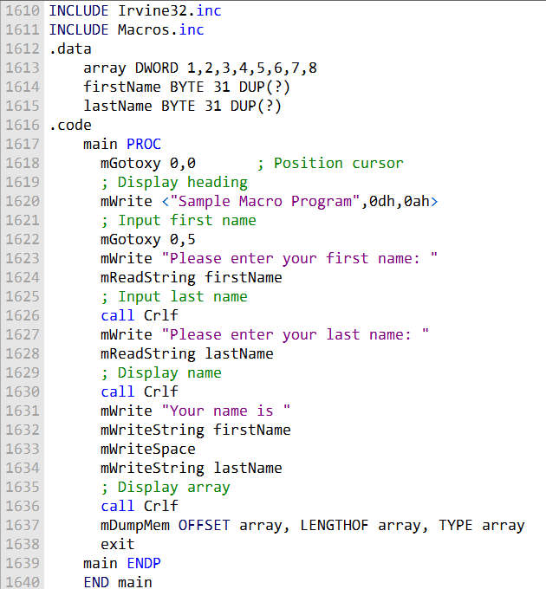

Purpose:

* Simplify common console and debugging tasks.
* Make code more readable and maintainable.

Macros Used:

1. **Input a string:** mReadString
2. **Set cursor position:** mGotoxy
3. **Display formatted output:** mWrite
4. **Display a string:** mWriteString
5. **Hex dump memory:** mDumpMem

Example:  
Instead of writing:

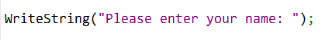

It can be rewritten using the macros as follows:

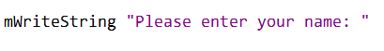

Or

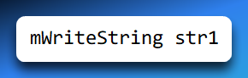

This approach reduces boilerplate and ensures safe, consistent handling of registers and memory.

Key Takeaways from Wraps.asm:

* Wrapper macros encapsulate low-level details. They preserve registers and prevent conflicts.
* They allow combining multiple actions into simple, readable statements.
* Using these macros makes assembly programs cleaner, easier to debug, and more maintainable.

Here are the review questions rewritten:

1. When a macro is invoked, does the assembler automatically insert CALL and RET instructions in the generated code? Explain.
2. Where is macro expansion handled - at assembly time or runtime?
3. What is the main advantage of using macros with parameters compared to macros without parameters?
4. Can a macro definition appear before or after the code that invokes it, as long as it is in the code segment? Explain.
5. How does replacing a procedure call with a macro invocation typically affect code size if the macro is called multiple times? Explain.
6. Can a macro contain data definitions like DW and DB? Explain.

Here are answers to the review questions:

1. False - CALL and RET instructions are not automatically inserted when a macro is invoked. The macro expansion is inserted directly into the code.
2. True - Macro expansion is handled by the assembler's preprocessor before the code is assembled.
3. Macros with parameters are more flexible since they can accept arguments from the caller. This avoids having to modify the macro definition for different uses.
4. True - As long as it is in the code segment, a macro can appear anywhere, before or after its usage. The assembler handles macros separately during preprocessing.
5. True - If a macro is invoked multiple times, the code will be expanded/duplicated each time, increasing the overall code size compared to calling a single procedure.
6. False - Macros can contain data definitions, though the data is inserted wherever the macro is expanded.

CONDITIONAL ASSEMBLY DIRECTIVES

Assembly macros can include conditional logic, repetition, and local symbols using **conditional assembly directives**. These directives are evaluated **at assembly time**, not runtime, giving macros much more power than simple text substitution.

Common Directives:

* **IF, ELSE, ENDIF** – Conditionally assemble blocks of code based on a specified condition.
* **IRP, IRPC** – Repeat a block of code for each parameter value passed to the macro.
* **REPT** – Repeat a block a fixed number of times.
* **WHILE, ENDW** – Repeat a block while a condition evaluates as true.
* **EXITM** – Exit macro expansion early, skipping remaining code in the macro.
* **LOCAL** – Declare symbols that are local to the macro, preventing naming conflicts.

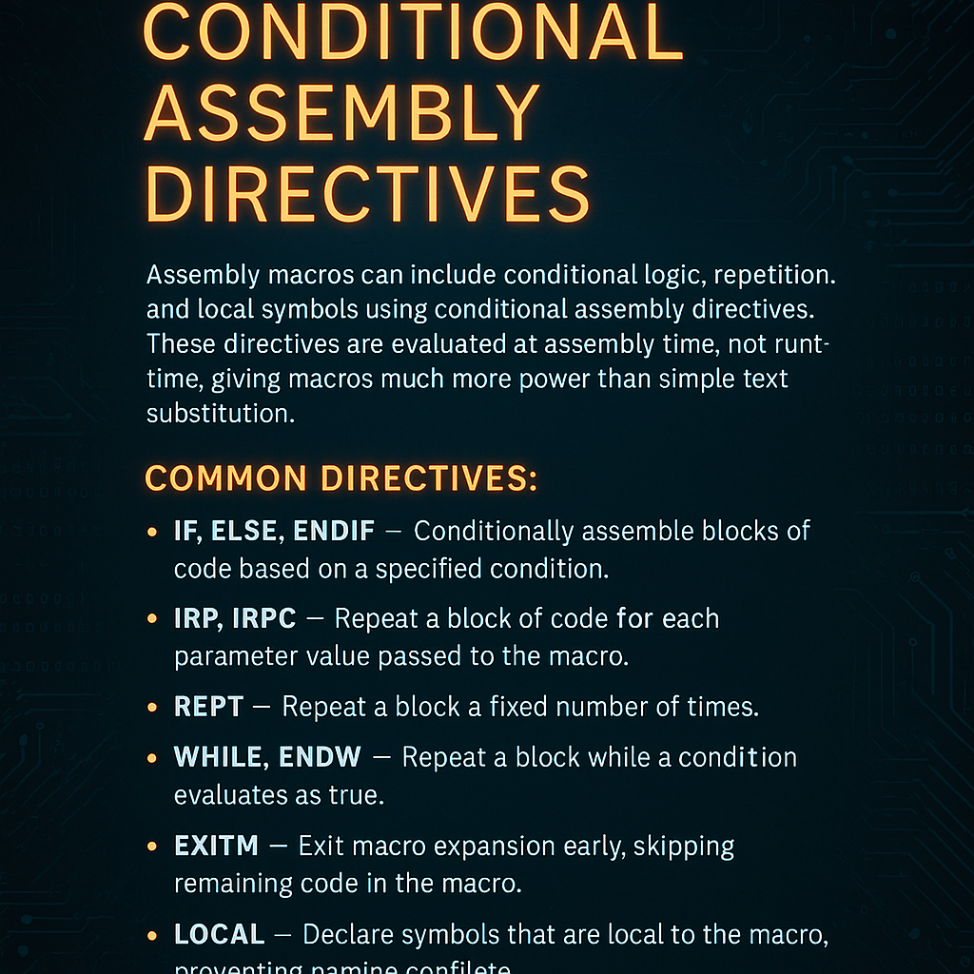

Key Points:

* These directives **operate at assembly time**, meaning the assembler decides which code to include or exclude in the final program.
* They allow macros to have **conditional logic, loops, early exits, and local symbols**, making macros far more versatile than simple text replacement.
* By combining these directives, complex, reusable, and safe macros can be created for a variety of programming tasks.

Conditional-assembly directives

Conditional-assembly directives can be used to control the assembly of code based on certain conditions.

Conditional-assembly directives are like "if-then" rules for your code. They tell the computer to only include certain parts of the code if a specific condition is true.

This makes your code more flexible because one set of instructions can change depending on what you need at that moment.

The Basic Structure

The general syntax follows this simple logic:

1. **Check a condition:** Is something true or false?
2. **Include code:** If it’s true, the computer assembles that part of the code.
3. **Skip code:** If it’s false, the computer ignores that part and moves on.

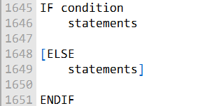

Why use them?

* **Flexibility:** You can write one macro that works in many different situations.
* **Efficiency:** You only include the code you actually need, which keeps the final program clean.

IF directive

The **IF** directive is like a fork in the road for your code. It tells the computer which path to take based on a specific rule.



How it Works:

* **The Check:** The computer looks at the condition you gave it.
* **If True:** It assembles (includes) the code right after the IF.
* **If False:** It skips that part and assembles the code after the ELSE instead (if you provided one).

Here are the most common tools used to control these conditions:

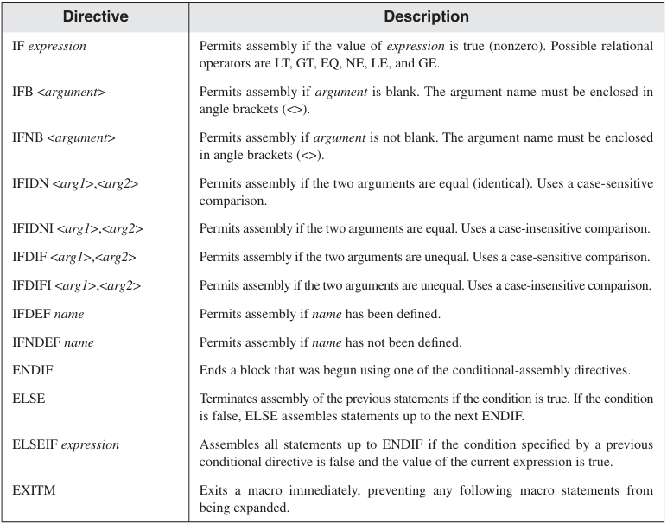

Table 2:

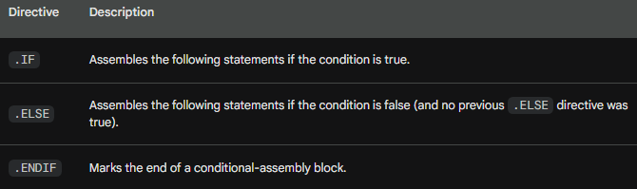

The following example shows how to use conditional-assembly directives to create a macro that can be used to print a message to the console:

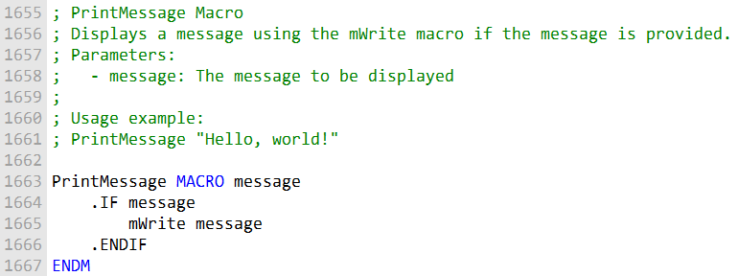

This macro takes a single parameter, message, which is the message to be printed to the console.

The IF directive checks to see if the message parameter is empty.

If it is not empty, the mWrite macro is used to print the message to the console.

Here is an example of how to use the PrintMessage macro:

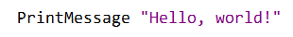

This will print the message "Hello, world!" to the console.

Conditional-assembly directives make macros **more flexible and adaptable**.

Example: A PrintMessage macro can use these directives to support **different message types** (e.g., error, warning, informational).

Conditional-assembly directives are **evaluated at assembly time**, not at runtime.

The **condition must be constant** and **cannot depend on runtime values**.

Checking for Missing Arguments

**Purpose:** Prevent errors caused by missing arguments in a macro.

**How:** Use conditional assembly directives:

* **IFB** – Checks if an argument is blank (missing).
* **IFNB** – Checks if an argument is not blank (provided).

Ensures macros handle optional or required parameters safely.

**Example:** Can wrap macro code in IFB/IFNB blocks to verify arguments before using them.

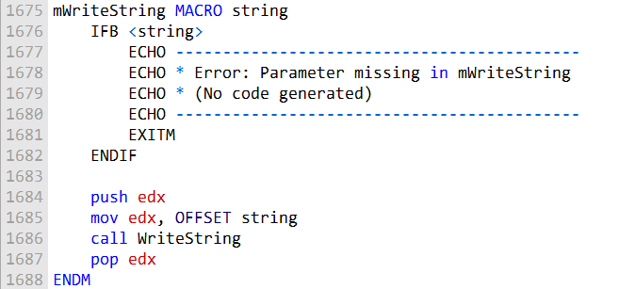

* Macro: mWriteString displays a string using the WriteString procedure.
* If the string argument is **missing**, the macro can:
  + Display an **error message** during assembly.
  + **Prevent code generation**, avoiding invalid instructions.

**Benefit:** Ensures macros are **used correctly** with the required arguments, improving safety and maintainability.

**Default Argument Initializers**

Macros can define **default values for arguments**, called **default argument initializers**.

This feature allows a macro to work even if the caller omits one or more arguments.

If an argument is **not provided** when the macro is called, the **default value** is automatically used.

This prevents errors due to missing arguments and allows macros to be more **flexible and reusable**.

Default arguments are evaluated at **assembly time**, just like all other macro logic.

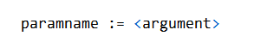

Spaces before and after the operators are optional.

Or

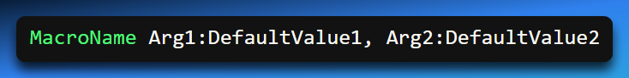

* Arg1 and Arg2 are macro parameters.
* DefaultValue1 and DefaultValue2 are used if the caller does **not** provide values.

For example, the following macro has a default argument initializer for the text parameter:

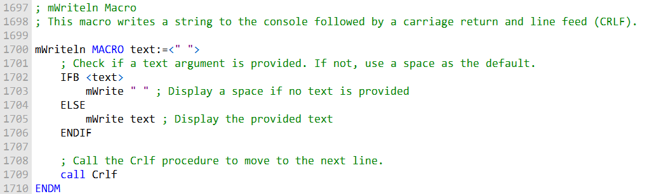

Display text followed by a newline, with a default value if no text is provided.

* Checks if a **text argument** is provided.
* If missing, uses a **space " "** as the default value.
* Calls the mWrite macro to display the text.
* Calls the Crlf procedure to add a **line break**.

Calling mWriteln with no arguments prints a **single space** followed by an **end-of-line**.

Ensures the macro works even if no argument is provided, using a **safe default**.

Or another example:

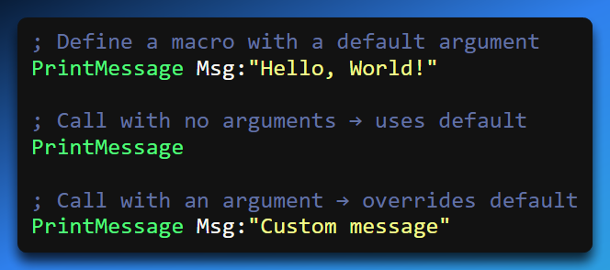

* In the first call, Msg is **not provided**, so "Hello, World!" is used.
* In the second call, the argument "Custom message" **overrides the default**.

**Benefits:**

* Makes macros more **robust** and **user-friendly**.
* Reduces the need for repetitive argument checking (IFB/IFNB) in simple cases.
* Supports creating **versatile macros** that work with minimal input.

Boolean Expressions

The assembler allows the following relational operators to be used in constant Boolean expressions:

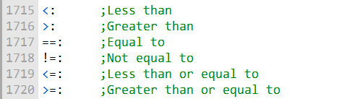

These operators can be used in conjunction with the IF and other conditional directives to control the assembly of code.

For example, the following code uses the IF directive to check if the value of the x variable is greater than 10:

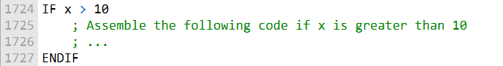

* Instructions within an IF block are **assembled only if the condition is true**   
  (e.g., IF x > 10).
* If the condition is false, the code is **skipped during assembly**, not at runtime.

IF, ELSE, and ENDIF directives

The **IF, ELSE, and ENDIF directives** are used to control the assembly of code based on certain conditions.

The IF directive checks the condition specified in its argument. If the condition is true, the statements following the IF directive are assembled.

If the condition is **false** and an **ELSE** block is present, the ELSE statements are assembled instead.

The **ENDIF** directive marks the **end of the conditional block**.

The following is an example of how to use the IF, ELSE, and ENDIF directives:

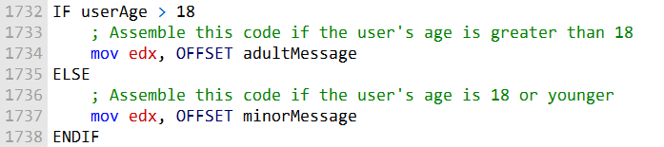

IF, ELSE, ENDIF are evaluated at **assembly time**, not runtime.

Example: Conditional Assembly in mGotoxyConst

**Purpose:** Move the cursor to specified coordinates while checking that the coordinates are valid.

**Parameters:** X and Y – must be **constant expressions**.

**Behavior:**

* Checks if X is between 0 and 79, and Y is between 0 and 24.
* If either value is out of range:
  + Displays a **warning message**.
  + Sets a **flag** and exits the macro.
* If values are valid:
  + Assembles code to move the cursor to the specified coordinates.

**Example Usage:**

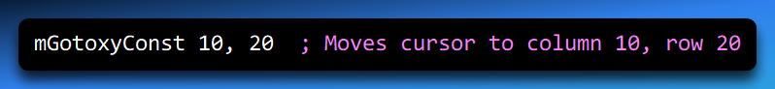

**Key Point:**

*Using IF, ELSE, and ENDIF inside a macro allows for flexible argument validation and conditional assembly of code, enabling more robust macros.*



The IFIDN and IFIDNI Directives

mReadBuf Macro Explanation

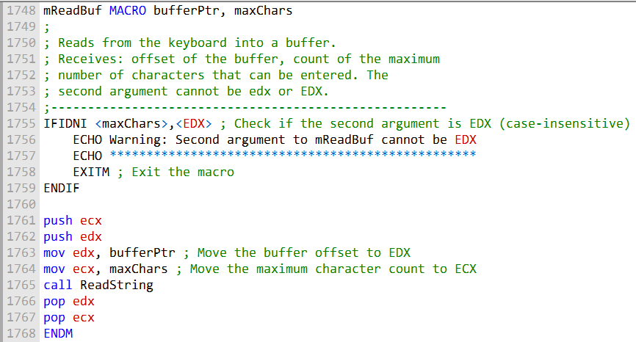

Purpose:

* Reads keyboard input into a specified buffer.
* Checks that the second argument (maxChars) is **not the same as EDX**, preventing register conflicts.
* If the argument is invalid, warns the programmer and exits the macro.

How it Works:

1. **IFIDNI – Case-insensitive comparison:**
   * Compares maxChars with EDX.
   * If they are equal (ignoring case), the macro:
     + Displays a **warning message** using ECHO.
     + Exits the macro using EXITM.
2. **ECHO – Assembly-time messaging:**
   * Prints warnings or messages to the console **during assembly**, not at runtime.
3. **EXITM – Early macro exit:**
   * Stops macro expansion immediately if a problem is detected.
4. **push and pop – Register preservation:**
   * push ecx / push edx saves the original register values on the stack.
   * After using ECX and EDX internally, pop edx / pop ecx restores the original values.
   * Prevents **register corruption** in the calling code.
5. **mov – Load registers:**
   * mov edx, bufferPtr → loads the buffer address into EDX.
   * mov ecx, maxChars → loads the max number of characters into ECX.
   * These are used by the ReadString routine to read input.

Summary:

* The macro **ensures safety** by checking arguments and preserving registers.
* If maxChars is invalid (EDX), it **warns and exits** at assembly time.
* Otherwise, it **reads keyboard input** into the buffer safely.
* Combines **conditional assembly**, **stack manipulation**, and **register setup** for robust macro behavior.



Summing a matrix row

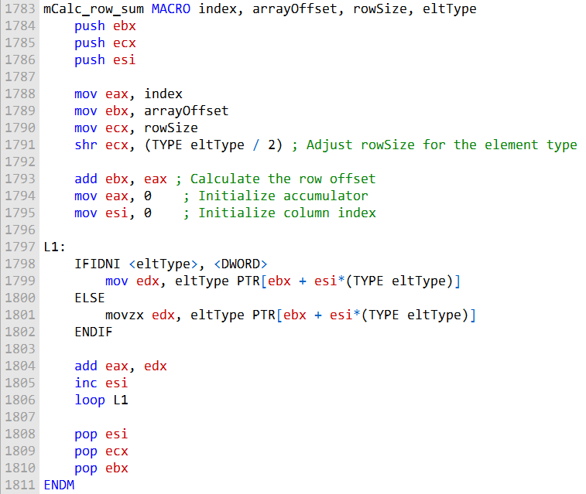

* The macro takes **four parameters**: index, arrayOffset, rowSize, and eltType.
* rowSize is adjusted based on eltType so it represents the **number of elements per row**, not bytes.
* The macro initializes registers and sets up required variables.
* It calculates the **row offset** and initializes the accumulator (EAX).
* Inside loop **L1**, an IFIDNI conditional checks whether eltType is DWORD.
* Based on this check, elements are read from memory using the **correct size**.
* Each element is **added to EAX**, and the column index is incremented.
* The loop continues until **all elements in the row are processed**.
* After completion, the macro **restores registers** by popping them from the stack.
* **Overall:** The macro computes the **sum of a row** in an array while correctly handling **different element types and sizes**.

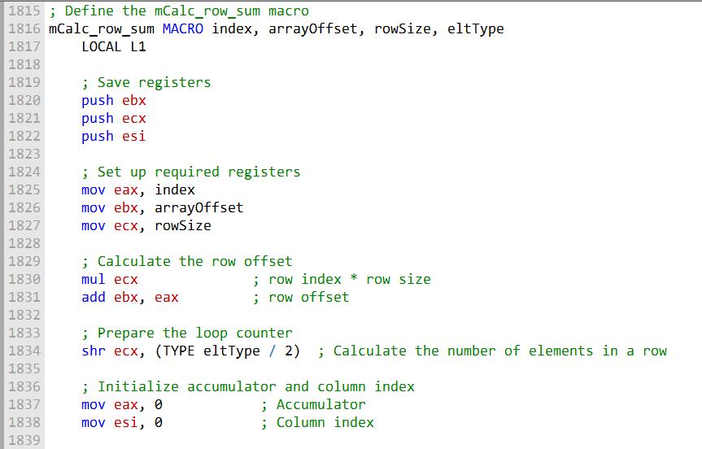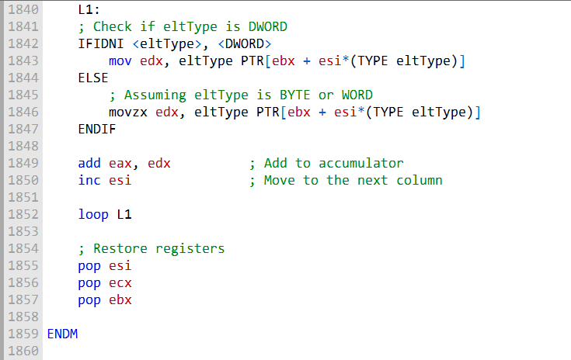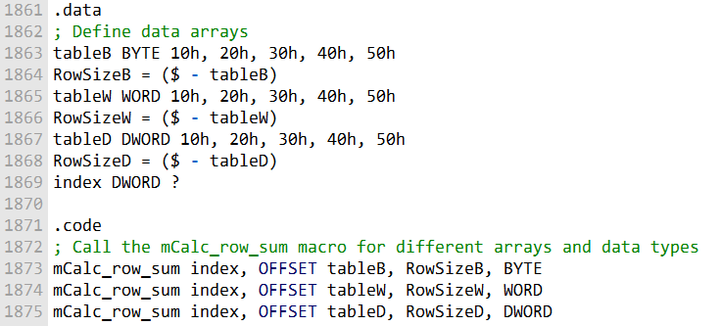

mCalc_row_sum Macro Explanation

Introduces a macro named **mCalc_row_sum** that calculates the **sum of a row** in a two-dimensional array.

The macro takes **four parameters**:

* index – row index
* arrayOffset – starting address of the array
* rowSize – number of bytes per row
* eltType – element type (BYTE, WORD, or DWORD)

Registers **EBX, ECX, and ESI** are pushed onto the stack to preserve their original values.

The **row offset** is calculated by multiplying rowSize by index and adding it to arrayOffset, yielding the starting address of the target row.

The macro determines the **number of elements per row** based on eltType:

* DWORD → no scaling required
* WORD → shift ECX right by 1
* BYTE → shift ECX right by 2

The accumulator (**EAX**) and column index (**ESI**) are initialized to 0.

Inside loop **L1**:

* An element is loaded from memory based on eltType.
* DWORD elements use mov.
* BYTE and WORD elements use movzx to zero-extend the value.
* The value is added to **EAX**.
* The column index (**ESI**) is incremented.

The loop continues until **all elements in the row are processed**.

After the loop, registers are **popped** to restore their original values.

The **.data section** defines three arrays:

* tableB (BYTE)
* tableW (WORD)
* tableD (DWORD)
* Each includes a calculated row size.

The **.code section** demonstrates calling mCalc_row_sum with each array and the appropriate element type.

The macro provides a **flexible and reusable way** to compute row sums in 2D arrays of varying data types while preserving register safety and readability.



SPECIAL OPERATORS FOR MACROS

Substitution Operator (&) in Macros

* Assembly language macros support **special operators** that improve flexibility and usability.
* One of the most important is the **substitution operator (&)**.

What & Does

* The substitution operator **forces macro parameters to be replaced with their actual argument values** during macro expansion.
* It is especially useful when a macro parameter must appear **inside a string literal**.

Why It’s Needed

* If you place a macro parameter directly inside a string, the assembler treats it as **literal text**, not a macro argument.
* This means the parameter name will not be replaced automatically.

Example: mShowRegister

* The mShowRegister macro displays a register’s name and its hexadecimal value.
* Example macro call:

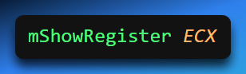

* To create a string that includes the register name, using regName alone inside a string **will not work**.
* The substitution operator & is required to insert the actual argument (ECX) into the string.

Correct Usage with &

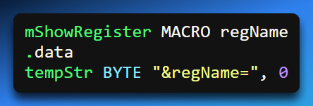

&regName tells the preprocessor to **substitute the argument value** into the string.

When the macro is expanded, the string becomes: **ECX=**

Key Takeaway

* The **& substitution operator** allows macro arguments to be correctly embedded inside strings.
* Without it, macro parameters inside string literals will **not expand properly**.
* This makes macros like mShowRegister more flexible and usable.

Expansion Operator (%) in Macros

In assembly language, the **expansion operator (%)** is commonly used in macros to evaluate expressions and expand text at assembly time.

It is especially useful when working with constants and text macros.

I. Evaluating Expressions with %

When used with TEXTEQU, the % operator forces the assembler to **evaluate a constant expression** and convert the result into an integer value, which is then stored as text.

This allows you to perform arithmetic during assembly rather than at runtime.

**Example:**



* The expression (5 + count) is evaluated at assembly time.
* % converts the result into an integer.
* sumVal becomes the text value "15".

This makes % especially useful for generating constants, offsets, or calculated values inside macros.

II. Flexibility for Passing Arguments

The **% expansion operator** provides flexibility when passing arguments to macros. If a macro expects a **constant integer argument**, % can be used to pass an **integer expression** instead of a literal value.

**Example:**

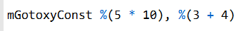

In this case:

* Each expression inside %(...) is evaluated at assembly time.
* The resulting integer values are passed directly to the macro.
* This allows arithmetic to be performed before the macro is expanded.

III. Expanding Macros on a Line

When the expansion operator (%) appears as the **first character on a source code line**, it instructs the assembler to **expand all text macros and macro functions** on that line.

This feature is useful for generating dynamic text during assembly.

**Example:**



Here:

* TEXTEQU creates a text macro containing the evaluated size of the array.
* The % at the start of the next line forces macro expansion.
* The echo statement displays the computed size during assembly.

This technique enables **dynamic text generation** based on compile-time values.

IV. Displaying Line Numbers for Debugging

Macros can also display the **line number** from which they were called, which is helpful for debugging.

The @LINE predefined assembler operator returns the current source code line number. A text macro such as LINENUM can reference @LINE and include it in error messages.

When a macro detects an error condition, it can display the line number in its output, making it easier to locate and fix issues in the source code.

V. Summary

The expansion operator (%) is a powerful and versatile tool in assembly macros. It enables:

* Compile-time evaluation of expressions
* Flexible passing of calculated arguments to macros
* Dynamic text generation during assembly
* Improved debugging through line-number reporting

Literal-Text Operator (< >)

The **literal-text operator (< >)** allows you to group characters and symbols into a **single text literal**. Its primary purpose is to prevent the assembler’s preprocessor from interpreting those characters as separate arguments or operators.

This operator is especially useful when a string contains **special characters** such as:

* commas (,)
* percent signs (%)
* ampersands (&)
* semicolons (;)

Without the literal-text operator, these characters may be misinterpreted by the preprocessor and cause errors or unexpected behavior.

I. Why It’s Needed

Some macros expect a **single string literal** as an argument. If the string includes special characters, the assembler may incorrectly parse the string as multiple arguments or macro operators.

For example, consider the mWrite macro, which expects a string literal as its argument. If you pass a string containing special characters **without** using the literal-text operator, the assembler may not process it correctly.

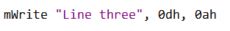

Without the literal-text operator, the **preprocessor interprets the string as multiple arguments**. In this situation, any text after the first comma is treated as a separate argument and is discarded, since the macro expects only one argument. To prevent this behavior, the string should be enclosed using the **literal-text operator   
(< >)**.

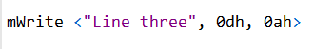

By doing so, the preprocessor treats **all characters inside the brackets as a single macro argument**, including any special characters. This ensures the string is passed correctly to the macro without being split or misinterpreted.

Literal-Character Operator (!)

The **literal-character operator (!)** serves a purpose similar to the literal-text operator, but at a finer level. It instructs the preprocessor to treat a **single predefined operator or special character as a literal character**, rather than interpreting it as part of macro syntax.

This is especially useful when you need to include characters that normally have a special meaning—such as < or >—inside a text literal.

I. Example: Preventing Misinterpretation of >

Consider the definition of the BadYValue symbol:



In this definition, the ! operator is used to prevent the > character from being treated as a **text delimiter**.

By prefixing > with !, the assembler is instructed to treat it as a literal character.

This ensures that the entire text enclosed within the < > brackets is preserved as **one complete text literal**.

II. Example: Using %, &, and ! Together

To see how these operators work together, consider a symbol named BadYValue and a macro called ShowWarning.

The ShowWarning macro:

* Accepts a text argument
* Encloses it in quotation marks
* Passes it to the mWrite macro

This can be implemented using the **substitution operator (&)**:

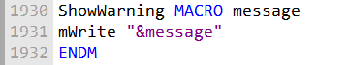

When ShowWarning is invoked with %BadYValue:

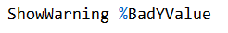

* The % operator **evaluates (dereferences)** BadYValue, converting it into its text value.
* The & operator substitutes that text into the macro.
* The ! operator (used in the original definition of BadYValue) ensures special characters like > are preserved.

As a result, the program runs correctly and displays the warning message:

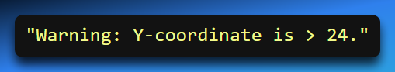

III. Summary

The **literal-text (< >)** and **literal-character (!)** operators provide precise control over how the preprocessor interprets special characters.

Together with the expansion (%) and substitution (&) operators, they allow you to:

* Preserve special characters inside text literals
* Safely pass text containing operators to macros
* Generate clear, correct output during assembly

MACRO FUNCTIONS

A **macro function** is similar to a regular macro procedure, but with one key difference: it **always returns a constant value**, either an integer or a string, using the EXITM directive.

I. Example: Checking if a Symbol Is Defined

The IsDefined macro function can check whether a given symbol has been defined.

* If the symbol is defined, it returns **true** (represented by -1).
* If the symbol is not defined, it returns **false** (0).

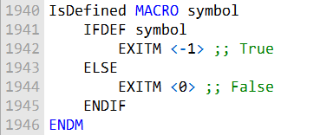

In this example, the IsDefined macro function checks whether a given symbol has been defined.

If the symbol is defined, it returns true (represented by -1); otherwise, it returns false (0).

II. Invoking a Macro Function

To use a macro function, **enclose its argument list in parentheses**.

For example, to check if the symbol RealMode is defined:

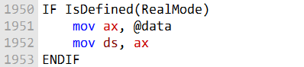

* If RealMode has been defined earlier in the assembly, the assembler will correctly assemble instructions that depend on this check.

Macro functions can also be used **inside other macros**, such as a Startup macro:

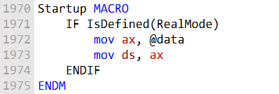

Conditional Assembly Based on Symbols

The IsDefined macro is especially useful when designing programs for different memory models.

You can use it to select which include file to use, depending on whether RealMode is defined.

I. Defining the RealMode Symbol

To use IsDefined effectively, the RealMode symbol must be defined. There are two common ways to do this:

In the program source:

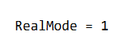

Via assembler command-line options:

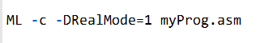

This approach allows you to control whether RealMode is defined when assembling your program.

II. Example Program: HelloNew.asm

The HelloNew.asm program demonstrates:

* The use of the macros described above
* Displaying a message on the screen
* Choosing the appropriate include file depending on whether RealMode is defined

It works for both **16-bit Real Mode** and **32-bit Protected Mode** programs.

III. Summary

* **Macro functions** always return a **constant value** (integer or string).
* They are **invoked with parentheses**.
* Useful for **conditional assembly** based on defined symbols.
* Make assembly programs more **versatile and adaptable** to different environments.

Questions

**What is the purpose of the IFB directive?**

The purpose of the IFB directive is to check if a macro argument is blank (empty). It returns true if the argument is empty and false if it contains any content. It's often used to handle cases where a macro expects specific arguments and needs to respond differently when arguments are missing.

**What is the purpose of the IFIDN directive?**

The purpose of the IFIDN directive is to perform a case-sensitive match between two symbols (or macro parameter names) and determine if they are equal. It returns true if the symbols are the same and false if they are different. This directive is helpful for ensuring that certain conditions are met within a macro.

**Which directive stops all further expansion of a macro?**

The directive that stops all further expansion of a macro is the EXITM directive. When EXITM is encountered within a macro, it halts the macro's execution, preventing any more macro expansion or code generation.

**How is IFIDNI different from IFIDN?**

The key difference between IFIDNI and IFIDN is their case sensitivity. IFIDNI performs a case-insensitive match, meaning it treats symbols or names as equal regardless of letter case. In contrast, IFIDN is case-sensitive and only returns true if the symbols or names match exactly, including their letter case.

**What is the purpose of the IFDEF directive?**

The purpose of the IFDEF directive is to check whether a particular symbol (usually a macro or a variable) has been defined earlier in the code. It returns true if the symbol is defined and false if it is not. IFDEF is commonly used to conditionally include or exclude code blocks based on the existence of specific symbols in the assembly program.

REPEAT BLOCKS

MASM provides several **looping directives** that allow you to generate **repeated blocks of statements at assembly time**. These include:

* WHILE
* REPEAT
* FOR
* FORC

Note: These loops **operate at assembly time**, meaning the conditions and counters must be **constant expressions** known during assembly.

I. WHILE Directive

The WHILE directive repeats a block of statements as long as a specific **constant expression** evaluates to true. Syntax:

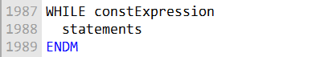

* The expression is evaluated **before each iteration**.
* When the expression becomes false (0), the loop terminates.
* Typically used for **conditional assembly**, such as generating repeated instructions or initializing tables.

For example, you can use the WHILE directive to generate Fibonacci numbers within a specific range, like so:

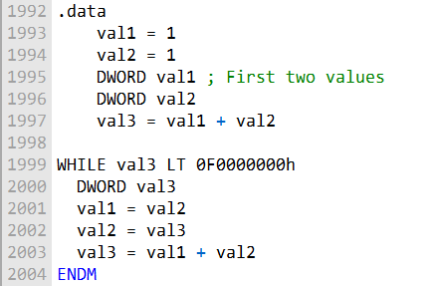

This code generates Fibonacci numbers and stores them as assembly-time constants until the value exceeds 0F0000000h.

II. REPEAT Directive

The REPEAT directive allows you to repeat a block of statements a fixed number of times at assembly time, based on an unsigned constant integer expression.

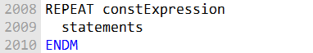

* Used when you need to **repeat code a predetermined number of times**, similar to the DUP operator.
* The count must be **known at assembly time**.

REPEAT Directive Example: Creating an Array

Suppose you want to create an array of WeatherReadings, where each WeatherReadings struct contains:

* A **location string**
* Arrays for **rainfall** and **humidity readings**

You can use REPEAT to generate the array for a total of WEEKS_PER_YEAR iterations:

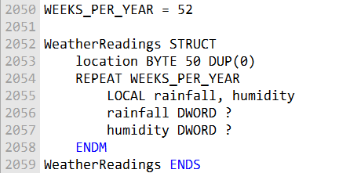

* Each iteration automatically generates one WeatherReadings struct.
* This reduces **manual coding** and ensures consistency for repeated structures.

III. FOR Directive

The FOR directive repeats a block of statements by **iterating over a comma-delimited list of symbols**.

* Each symbol in the list represents **one iteration** of the loop.
* Useful when you want to perform **a set of operations for each item** in a list of symbols.



FOR Directive Example: Student Enrollment

Suppose you want to create multiple SEMESTER objects for student enrollment in different semesters.

* The loop iterates over a **list of semester names**.
* Generates corresponding SEMESTER objects for each semester.

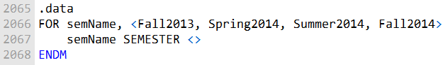

This code generates SEMESTER objects with different names for each semester.

**FORC Directive:**

The FORC directive repeats a statement block by iterating over a string of characters. Each character in the string represents one iteration of the loop:



* Each iteration produces a SEMESTER object with a **different name**.
* This makes managing student enrollments over multiple semesters easier.

IV. FORC Directive

The FORC directive repeats a block of statements by **iterating over each character in a string**.

* Each character represents **one iteration** of the loop.
* Useful when you need to **process or generate code for each character** in a string.

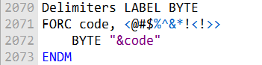

FORC Directive Example: Character Lookup Table

Suppose you want to create a **character lookup table** for non-alphabetic characters.

* The loop iterates over a string of special characters.
* Generates a corresponding entry in the lookup table for each character.

Here's the revised and expanded code with added explanations:

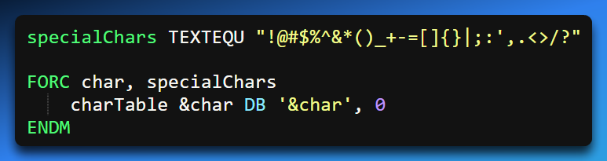

* Each table entry contains the **ASCII value** and the **character itself**.
* Helps automate repetitive tasks for handling multiple symbols or characters.

Advanced Example: Linked List Creation

You can also use loops like FOR or FORC to generate **structured data**, such as a linked list:

A ListNode structure contains:

* A **data area** (NodeData)
* A **pointer** to the next node (NextPtr)

By iterating with a loop, you can define and populate multiple ListNode objects.

This allows you to **programmatically build a linked list** at assembly time.

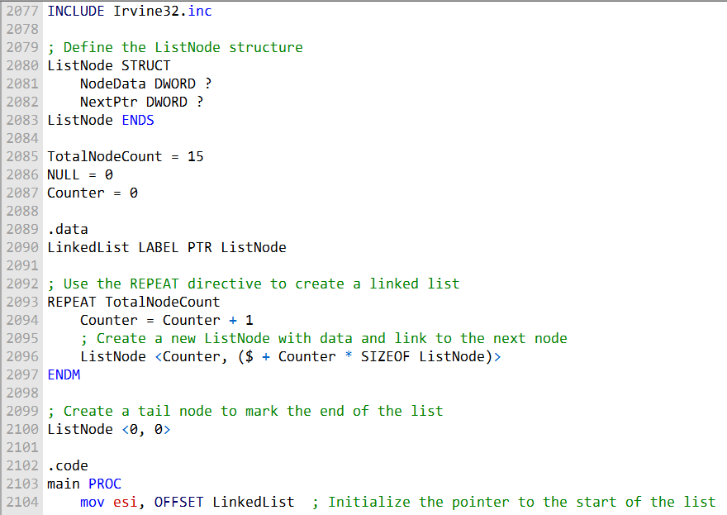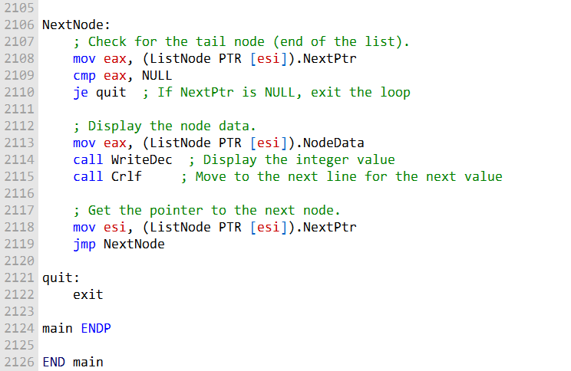

Program to illustrate what we have learnt above:

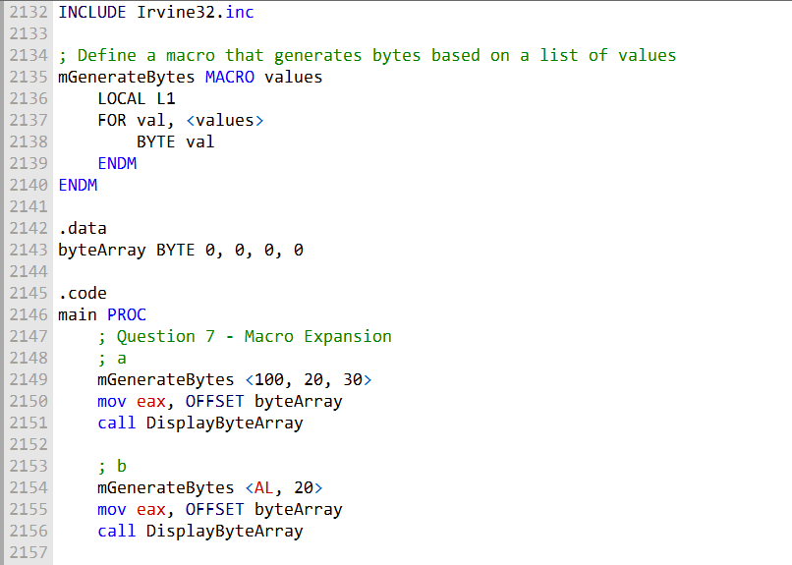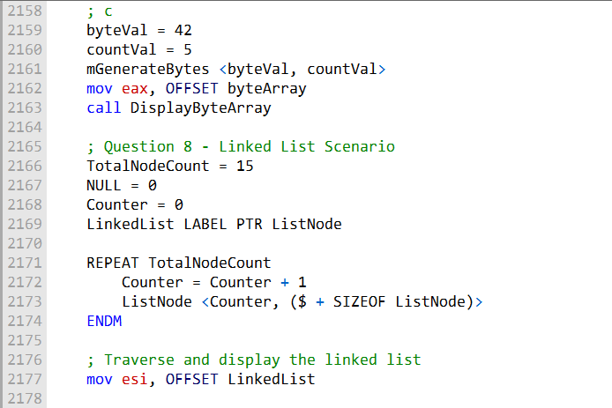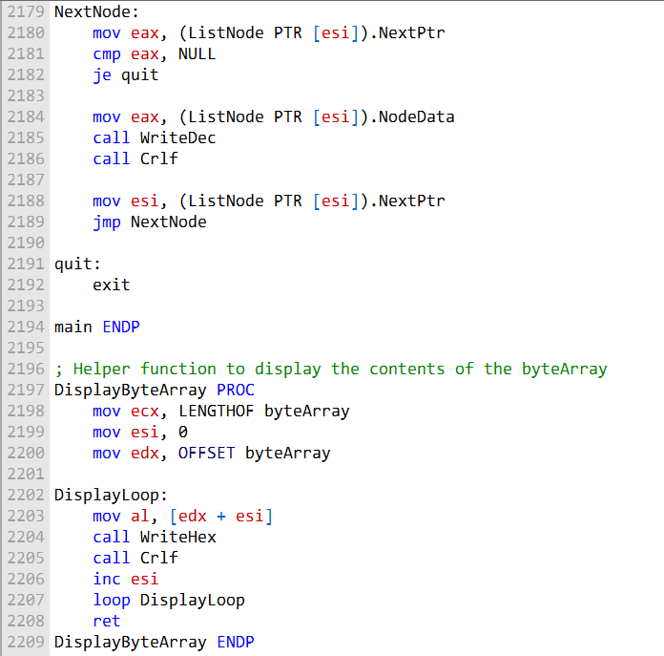   
2210 It's gonna be **END main** you know...👊

